WEllbeing at HOME

A compilation of practical activities for parents and caregivers to use at home to support children’s wellbeing

  - 

  - 
  - 

  - 

  - 

  - 

Contents
Introduction 5
What is Covid-19? 5
What is Wellbeing? 6
What is this Handbook for? 6
Who is this Handbook for? 7
How do I use this Handbook? 7
Tips for Caregivers 8
ME AND MY EMOTIONS 10
I am Unique 11
1. Tree of Life 11
2. My Flag 12
3. Mirror in the Box 13
4. River of Life 14
Relaxation 15
5. Balance Yourself 15
7. Things That Make Me Happy 17
8. I can Calm Myself Down 18
9. Being Mindful 19
Emotions 20
10. I am Aware of My Emotions 20
11. I Can Name and Describe My Emotions 21
12. I can Share my Ideas and Feelings 22
13. Expressing Feelings and Fears 23
14. Mirror Game 24
15. I can Deal with Difficult Emotions 25
MY FRIENDS AND COMMUNITY 26
Friendship 27
16. Friendship 27
17. Taxi Game 28
18. I can Listen to Others 29
19. My Garden of Support 30
Supporting Each Other 31
20. Lean on Me 31
21. Story Telling 32
22. Sharing Positive Feedback 33
23. Who is Your Hero? 34
24. I can Respect and Value People Who Are Different 35
25. I can Respect and Value People who have a Disability 36
26. I can Understand How Others Think or Feel 37
27. We can Take Care of Our Home Together 38
28. We can Continue Our Daily Activities 39
29. We can Help One Another Make Healthy Choices 40
30. Our Colorful Faces 41
31. Our Strengths 42
32. Working Together 43
MY HEALTH AND SAFETY 44
My Health 45
33. Clean Hands Detective 45
34. I can Sleep Regularly 46
35. I can Eat Healthily 47
36. I can Stay Active 48
37. We Can Stay Active Inside 49
38. We Can Stay Active in Small Groups 50
39. I can Manage Stress 51
40. Drawing Together 52
41. Paper Puppet Making 53
My Safety 54
42. Tone and Body Language 54
43. No- Go- Tell 55
44. Community Mapping 56
MY BRAIN 57
Focus and Plan 58
45. I can Remember 58
46. Memory Market 59
47. This Reminds Me 60
48. I Can Focus on a Task and Ignore Distraction 61
49. I Can Work with Others 62
50. We can Learn to Concentrate 63
51. We can Learn to Plan Our Day 64
52. We can Learn to Ask for Help 65
53. Why? Because 66
54. Stop 67
55. The Spelling Face 68
56. We can Love and Practice Reading 69
57. Squares 70
COVID-19 71
Activities for Covid-19 72
58. Virus Catch 72
59. I can Share Information I Know is True 73
60. I can Challenge Myths and Stereotypes 74
61. Coloring for wellbeing 75

Introduction

What is Covid-19?

Coronavirus disease (COVID-19) is an infectious disease. The virus spreads primarily through droplets of saliva or discharge from the nose when an infected person coughs or sneezes.
Symptoms include:
- Cough
- Headache
- Fever
- Difficulty breathing
Here are some ways to prevent and slow down transmission:
- Regularly and thoroughly clean your hands with soap and water or an alcohol-based hand rub.
- Maintain at least 1 metre (3 feet) distance between yourself and others outside of your household.
- Avoid going to crowded places.
- Avoid touching eyes, nose and mouth.
- Follow good respiratory hygiene: cover your mouth and nose with your bent elbow or tissue when you cough or sneeze. Then dispose of the used tissue immediately and wash your hands.
- Stay home and self-isolate even with minor symptoms. If you need to leave your house, wear a mask to avoid infecting others.
- If you have a fever, cough and difficulty breathing, seek medical attention, but call by telephone in advance if possible and follow the directions of your local health authority.
- Keep up to date on the latest information from trusted sources, such as WHO or your local and national health authorities.

If this Activity Book is used in communal spaces or with anyone outside your household, make sure that you:
- Keep at least 1 metre between people.
- Wash your hands with soap and water before and after practicing the activity.
- Clean any spaces, objects or props you used with disinfectant.

What is Wellbeing?

Children are especially in need of care and protection when faced with difficult circumstances.
Children have different needs that need to be met in order for them to be happy and healthy. These include physical (biological and material), cognitive, emotional and social-cultural wellbeing.

Children’s holistic wellbeing:
Confidence, opportunities to learn, develop and pursue goals.

Feeling safe and supported, self-worth, sense of control, hope for future, ability to feel and express emotions
Freedom from harm, basic needs (water, food, shelter), ability to play and be physically active.
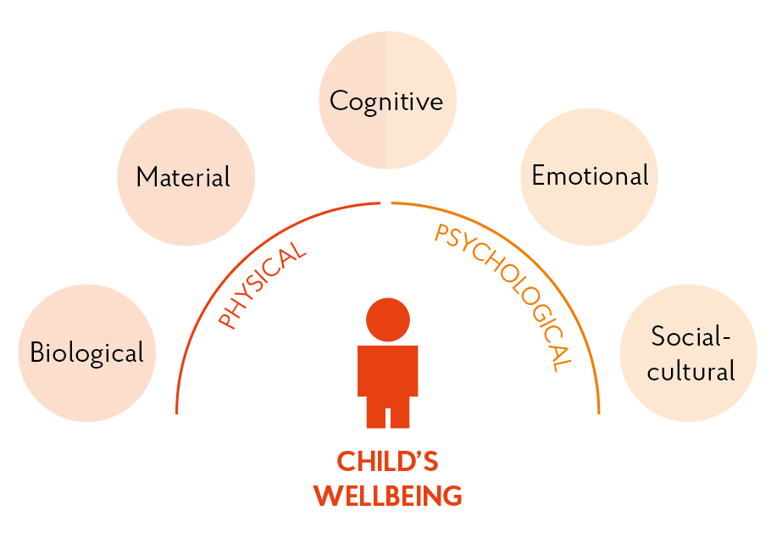
Sense of belonging, ability to interact, solve problems with others and communicate

What is this Handbook for?

This handbook includes a collection of activities to support children’s (and adults) physical, social, emotional and cognitive wellbeing. Participating in these activities can help children (and adults) to cope with the current situation, whilst also providing them with important skills for the future.
The activities in this book are fun! Even if the child has no apparent emotional difficulties, most children will benefit from these activities.
Activities are divided into 5 chapters that focus on developing key skills:
Me and My Emotions
- I am unique: Develop ideas of self and self-worth.
- Relaxation: Relax, calm down and be mindful.
- Managing Emotions: Understand, talk about and manage emotions and feelings in a positive way.

My Friends and Community
- Friendship: Value friendship, trust and listen to others.
- Supporting Each Other: Relate to others, understand others’ feelings and behavior, respect differences and interact in a positive way.

My Health and Safety
- My Health: Be healthy and active
- My Safety: Recognise dangers and ask for help

My Brain
- Focus and Plan: Focus our attention, organize ourselves and exercise our brains.

Covid-19
- Activities for Covid-19: Protect ourselves and manage information.

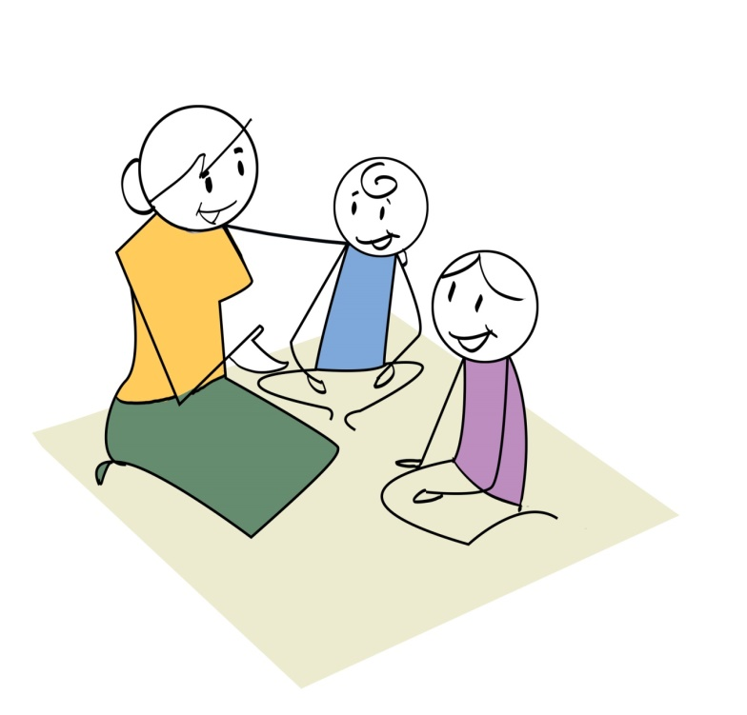
Who is this Handbook for?

- Parents and Caregivers can use this handbook to get ideas for activities to do at home with your children with minimal resources and space.
- Children can look for activity ideas to do alone, or with your siblings, friends or family members.
- Facilitators and teachers can use these activities in Child Friendly Spaces (CFS), Temporary Learning Spaces (TLS) or schools, once they reopen.

How do I use this Handbook?

- We encourage you to do one activity a day so that children have regular interaction with the content.
- If you aren’t able to do activities regularly, this is fine. You can simply select specific activities you think are most suitable for your needs and use them as and when you wish.
- Make sure you mix it up! Use activities from different sections so that different skills are practiced.
- Some activities are appropriate for all age-groups, whilst others are better suited for younger or older children. Many activities are also suitable for adults. Options for adapting activities for different age groups have been included. You can also think of ways you might be able to adapt activities to suit your needs.
- All activities can be done by two people, but may be more fun for larger groups of siblings, peers and family members.
- If leading activities with children, make sure you think about any potentially sensitive topics in advance and carefully consider how you might approach discussions in a sensitive way.
- If doing activities with people outside of your household, make sure you follow appropriate social distancing and hygiene rules (see section above).

Tips for Caregivers
Managing stress
- People have a range of reactions to stress. Boys and girls of different ages react in different ways. This may include: change in sleep patterns, anger, fear, withdrawal and bedwetting.
- Try to be patient and find ways to manage stress for the whole family. Singing, games, dancing or slow breathing can help everyone.
- If children are upset, tell them you understand, and that it is very common to react this way.
- Try to keep a routine. Do the same things at the same time every day.
- Talk to your child. This can help them relieve stress and develop coping, communication and social skills. Listen to them and answer their questions. This encourages curiosity and expression of feelings.
  - 0-2 years old: chat about daily activities. Encourage them by talking back when they imitate sounds.
  - 3-6 years old: ask questions and respond to their questions. Start the day by discussing plans and end by recounting everything you both did.
  - 7 years old +: talk to your child about his/her friends and ways to manage their distress.
- Stay connected to friends, teachers and family to help you and your children cope. If you can’t meet up, write or draw pictures, send messages or speak on the phone.

Positive Care:
- Instead of scolding or punishing, use positive words to encourage your child. Reward positive bevahiour.
- Be firm, consistent, fair and kind when handling misbehaviour. Make consequences clear in advance.
- If your child starts to misbehave, stay calm and give options for how to proceed. For example: “time out”; redirect the child to help with chore; breathing or stretching to calm down; redirecting to a different activity.
- If you are frustrated, pause and breathe deeply before you respond.
- Show your child the behavior you want to see. Treat them with respect and they will be more likely to treat others with respect and respect themselves.
- Reassure your child that things will be OK and that you will help them to continue learning and be healthy.

Caring for yourself:
- As a caregiver, your own wellbeing is very important, especially during times of stress.
- Your children will feel more relaxed and better able to cope if you yourself are able to stay calm and healthy.
- Explain that sometimes you also feel uncertain, frustrated or worried. Remind them that you are all OK.
- Show your children how you take care of yourself – do whatever helps you cope the best and is healthy.
- Take a break when you need it. Try: listening to music, singing, exercising or dancing, talking or sending messages to friends and family.

Remember
- Supporting your children can feel overwhelming. This is normal.
- It is important that you spend time with your children.
- You are not alone – a lot of people are experiencing the same challenges as you.

ME AND MY EMOTIONS

I am Unique

Tree of Life

Aim
Relax, feel secure, and to use your imagination.
Age | All ages
Time | 20 min
Materials
None
Instructions
- Stand up straight.
- Close your eyes. Imagine you are a tree. Your feet are roots and your arms are branches.
- Take slow, deep breaths in and out. Breath in energy from the ground. As you breathe out, let your roots grow deep into the soil.

- Sway in the wind.
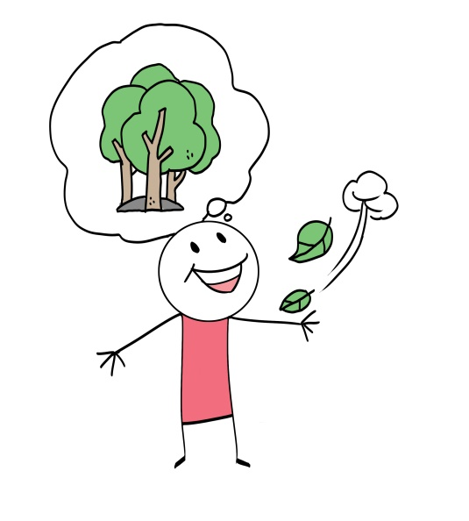
- Your tree is always there. Whenever you want to feel strong and calm, you can plant your feet and grow roots again!
LET’S TALK!
- How did it feel – was it reassuring?
- Do you feel differently after the exercise?

Variations
- Tell a short story about trees to introduce the activity.
- Introduce imaginary sunshine, rain, or very windy weather.
- Do the exercise sitting down.
- Play relaxing soft sounds of forest and wind blowing in background.
- Do it in pairs, reflecting each other’s movements.

My Flag

Aim
Express imagination, increase self-confidence
Age | 6 and older
Time | 55 min
Materials
Coloured pens/pencils, paper
Instructions
- Make a flag that reflects who you are. Examples: heritage, family, likes, dislikes, something you are proud of.

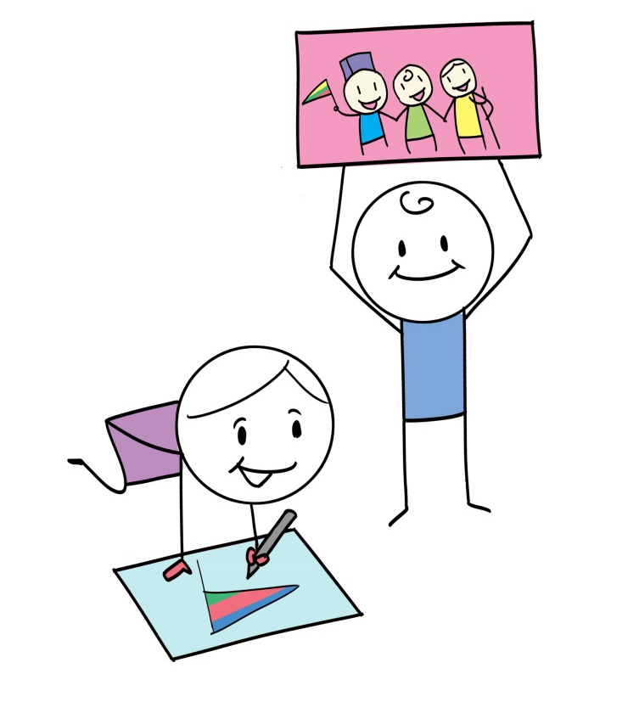
- Talk about your flag and put it up somewhere.

LET’S TALK!
- What are your qualities?
- How does it feel to share your thoughts?

Variations
Use anything you can find. Examples: leaves, twigs, fabric, string etc.
Create multiple flags about your background, personality or dreams. Attach them to a piece of string to hang in the house.

Mirror in the Box

Aim
Enhance self-confidence and self-respect.
Age | All Ages
Time | 15 min
Materials
A cardboard box with a lid and a mirror glued inside at the bottom. Prepare this beforehand.
Instructions
- This box contains the picture of someone really precious and important that you should respect and take good care of.
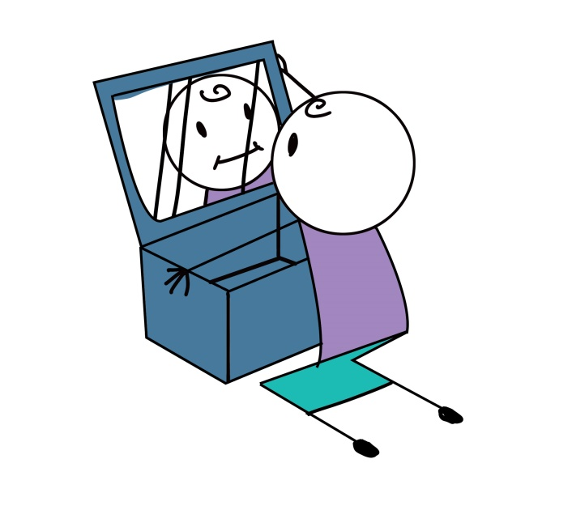

- Take turns to look inside the box, secretly, and see your reflections.

LET’S TALK!
• Were you surprised?
• What is the message?
If you do this activity with several children in the same group, agree that only respectful and positive comments can be given to others.

Variations
None specified

River of Life

Aim
Reflect on the past, present and future.
Age | 6 and older
Time | 50 min
Materials
Colour pens/pencils, paper (3 sheets/child)
Instructions
- The first paper is ‘past’, the second is ‘present’, the third is ‘future’.
- Draw a river along all 3 papers. The river is your life.

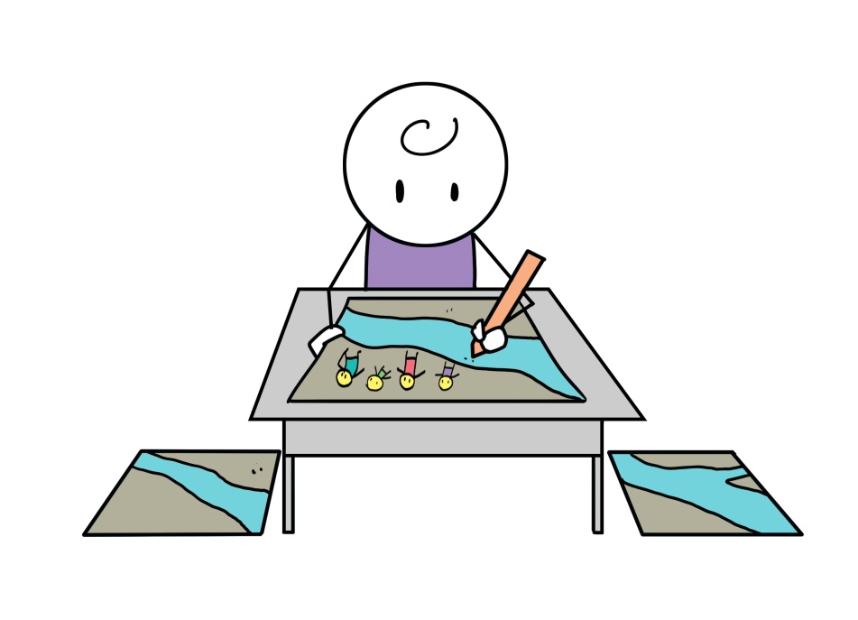
- Draw or write everything you feel is important in each stage. Examples: events, people, places, achievements, emotions, hopes and dreams.

LET’S TALK!
- What is important in your life and why?
- How do these change over time?

Variations
- Use small objects. Examples: flowers, feathers, string, buttons, etc.
- Vary reflection questions for different ages.
- Do separate session for past, present and future.

Relaxation

Balance Yourself

Aim
Enhance balance and calm down
Age | All ages
Time | 15 min
Materials
None
Instructions
- Copy one of the positions in the pictures
- Try to keep your balance for as long as you can

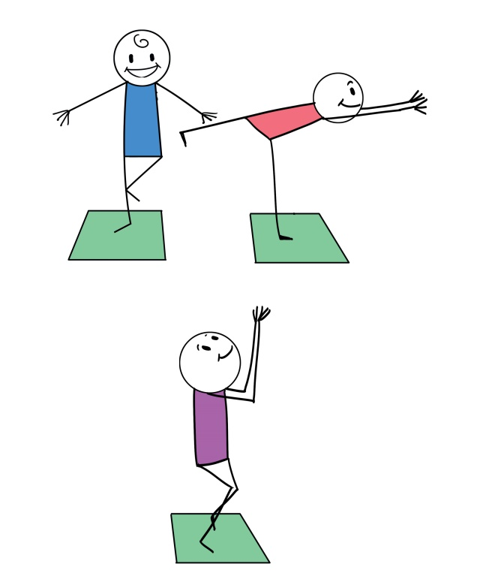
- This is not a competition. Different children have different capabilities.

LET’S TALK!
- How did you feel?
- How can this exercise be helpful?

Variations
Walk along a real or imaginary line on the floor without falling over.

- Muscle Relaxation
Aim
Releasing tension
Age | 6 and older
Time | 20 min
Materials
None
Instructions
- Focus on different muscles in our body. Examples: hands, arms, shoulders, face, stomach, legs, feet.
- Make each muscle tense, one at a time. Hold for 5 seconds, then release.

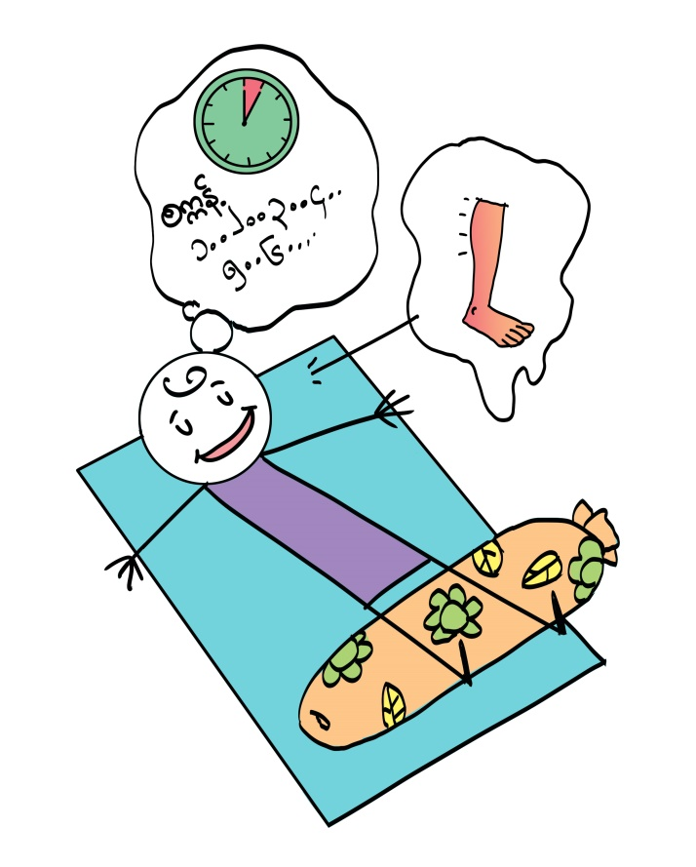

LET’S TALK!
- What did you feel?
- This can be useful when you can’t sleep, feel angry or have a lot of energy

Variations
- Name the muscles. Examples: biceps, triceps, hamstrings etc.
- Hands, arms, jaw, legs: imagine you are squeezing an object, such as a ball, between each body part. Face and nose: imagine a fly has landed on your nose and you need to make it go away without using your hands.
- Get children to lead the activity for others.

Things That Make Me Happy

Aim
Create a sense of control
Age | 6 and older
Time | 30 min
Materials
Pencil, paper, a jar or box
Instructions
- Get comfortable. Close your eyes
- What makes you HAPPY? What makes you feel SAFE?
- Write or draw it on a piece of paper

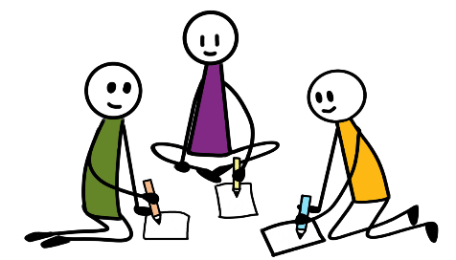

- Crunch the paper into a BALL.
- Put it into a jar or box
- When you feel SAD or WORRIED, take out a paper from your jar and remember the things that make you happy.

LET’S TALK!
- Do you think you can change how you feel and how you act? How?
- Let them talk about their feelings and find solutions. Don’t interrupt, don’t judge and don’t tell them they are ‘wrong’.
- How can this exercise be helpful?

Variations
Draw your person, place or feeling and keep it visible where you live

I can Calm Myself Down

Aim
Calming yourself down
Age | All ages
Time | 30 min
Materials
None
Instructions
- Sit up straight. Put one hand on your belly
- Breathe in slowly for 4 seconds. Imagine you are smelling a flower
- Hold the smell in your nose for 2 seconds
- Breathe out of your mouth for 4 seconds. Imagine you are blowing out a candle.

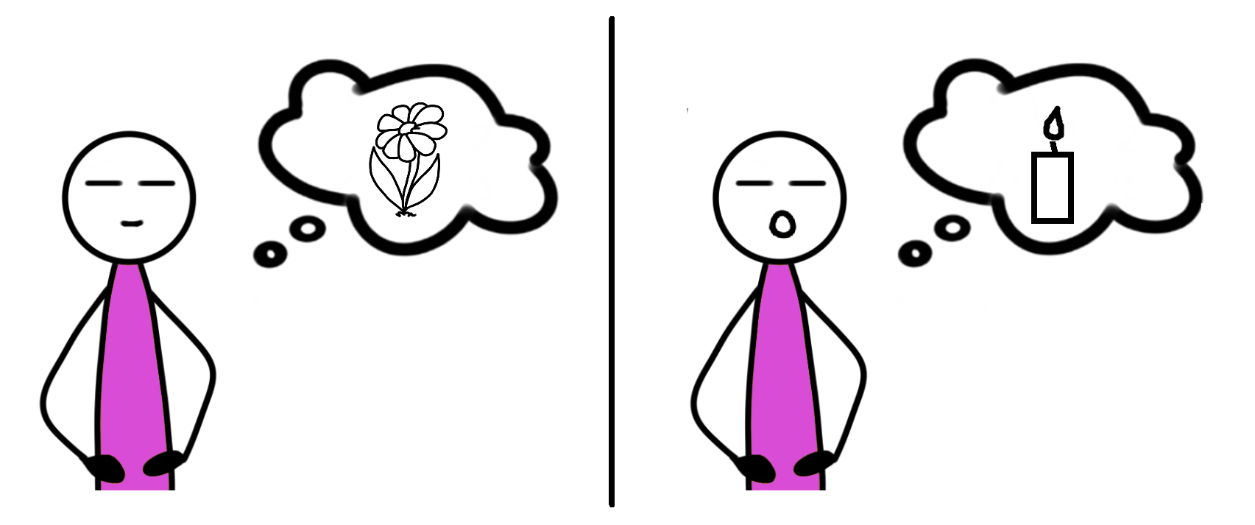

LET’S TALK!
- When do you need to calm yourself down?
- Why is it helpful to calm yourself down?
- How do you think breathing can help calm you down?
- Explain that there is a connection between feelings and behavior. When they feel scared or stressed, they can use breathing to stay peaceful and calm.

Variations
- Imagine someone you love is with you, hugging you. You are sending them love too.
- Sit back to back with a partner and feel each other’s breaths. Breathe in time with each other. OR lie on your back and put an object on your belly. Feel it go up and down as you breathe.
- As you breathe out, pretend to blow bubbles of happiness and love around the room OR choose a colour for bad feelings to breathe out and for good feelings to breathe in.
- Create a ‘mantra’, examples: “I love myself”, “I am strong”, “I am proud of myself”. Repeat it to yourself whilst doing the above breathing exercise.

Being Mindful

Aim
Observing and Noticing
Age | All ages
Time | 30 min
Materials
None
Instructions
- Look around for 5 things you can see. Say them out loud. Examples: cup, tree, pencil.
- Think of 4 things you can feel. Say them out loud. Examples: the hair on my neck, the mattress, the wind.
- Listen for 3 sounds. Say them out loud. Examples: a dog, someone singing, a car.
- Think of 2 things you can smell. Say them out loud. Examples: cooking, the soil, rain.
- Think of 1 thing you like to taste. Say it out loud.

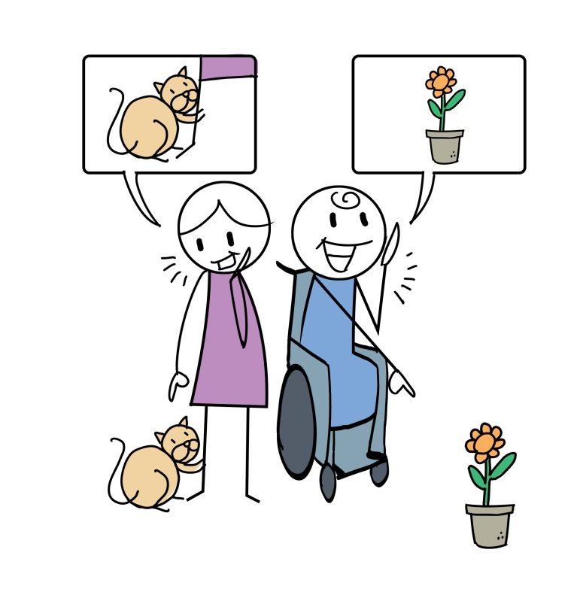
LET’S TALK!
- Did you notice more things than you normally would?
- Why is it important to be mindful and notice things around you?
- How do these things make you feel?

Variations
Concentrate for longer on each sense. Talk about exactly what you feel, see, hear etc and how it makes you feel. Talk about how the senses can affect your feelings and mood.

Emotions

I am Aware of My Emotions

Aim
Being in touch with emotions
Age | All ages
Time | 30 min
Materials
None
Instructions
- One person acts out a feeling. Examples: happy, brave, angry, scared, sad, hopeful
- Others try to guess it.

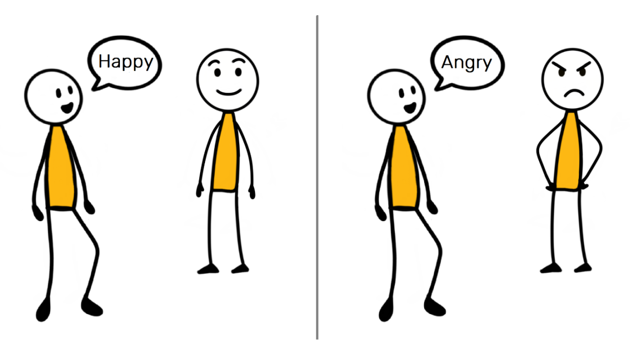
- Then play again with a new feeling.

LET’S TALK!
- What makes you feel happy at home? Worried? Hopeful? Sad?
- How do you feel today? How did you feel yesterday?

Variations
For older children:
- Instead of acting, each draw an emotion on paper. Stick it on someone else’s forehead. They ask for clues until they guess the emotion. You can also do this with objects, people, animals etc.
- Draw different emotions and use them each day to show each other how you are feeling. Talk about why you feel that way.

I Can Name and Describe My Emotions

Aim
Identifying and talking about emotions
Age | 6 and older
Time | 30 min
Materials
None
Instructions
- Face away from each other. Think of a feeling.
- Say 1-2-3-Go!
- Turn around. Act out your feeling.
- Guess the other person’s feeling

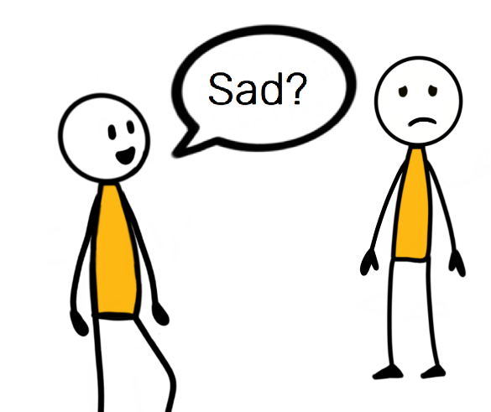

LET’S TALK!
- How can you tell how others feel?
- How can you tell others how you feel?

Variations
- Link emotions with colours or animals that represent them. Examples: red = angry, blue = calm, monkey = happy, parrot = excited.
- Act out different animals, and link them with emotions they are similar to.

I can Share my Ideas and Feelings

Aim
Sharing ideas and feelings
Age | 6 and older
Time | 30 min
Materials
Paper and pencils
Instructions
- Draw something that expresses what you are feeling right now. Example: a rainbow = hopeful
- Take turns to show your pictures to each other. Others will guess what it is.

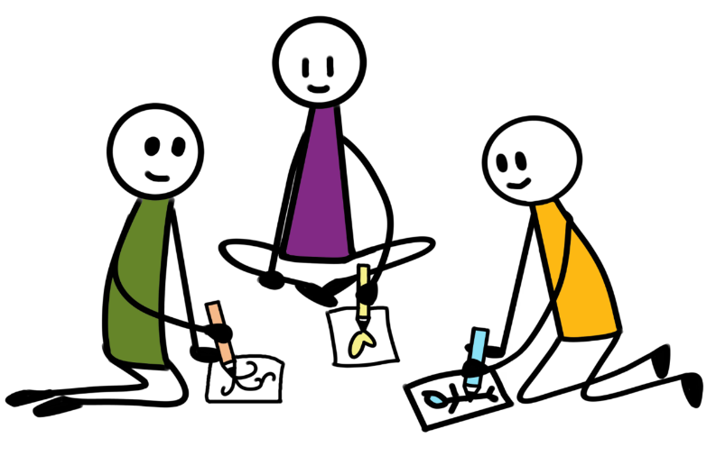

- If they don’t guess correctly, tell them. Example: I feel hopeful (like a rainbow)
- Do the same thing, but draw an idea you have. Example: a pot on the stove = I want to help cook tonight

LET’S TALK!
- Which of the ideas or feelings do you feel happy about?
- Why is it important to share our ideas and feelings?

Variations
None specified

Expressing Feelings and Fears

Aim
Talking about feelings
Age | 6 and older
Time | 80 min
Materials
Paper and pencils, and small objects (examples: stones, bottle tops)
Instructions
- What feelings do girls and boys have when they stay home for a long time? Draw a chart of these feelings (examples below).
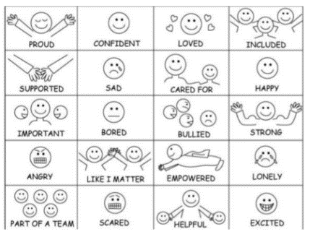
- The leader will say different feelings


SAD
- If the feeling is on your chart, cover it with a stone
- Say BINGO when you fill in a straight line
- Talk to children about their feelings, and listen to them carefully. Tell them you are there for them.

LET’S TALK!
- Which feelings do you feel more often when you stay home all day?
- How can you deal with feelings that make you feel bad?
Variations
For younger children, draw the grid beforehand.

Mirror Game

Aim
Strengthen awareness of emotions.
Age | 6 and older
Time | 20 min
Materials
None
Instructions
- Stand opposite each other. One person is a ‘mirror’.
- Call out a positive emotion. Examples: strength, courage, bravery, happiness, peacefulness.
- Act the emotion. The mirror copies you.

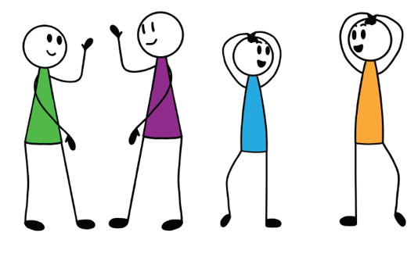
- Take it in turns.

LET’S TALK!
- How do you feel when you see someone is sad? Happy? Angry? Brave?
- How can you help others talk about their feelings?
- How can you talk about your feelings?

Variations
- Do this sitting down.
- Use this for stretching. The leader does stretches, and the mirror copies.
- Have one leader. All the others have to copy their emotions. Include other actions. Examples: clap, stand on one leg, dance, washing hands, cleaning. Walk around as you do it.

I can Deal with Difficult Emotions

Aim
Identify difficult emotions and respond to them.
Age | 6 and older
Time | 70 min
Materials
Color pens/pencils, large piece of paper
Instructions
- Draw a circle. Write ‘emotions’ in the middle.
- Write and draw as many different emotions as you can around the circle.
- Circle the words that feel bad or difficult.
- Write about what people do when they feel difficult emotions. Examples: fight, shout, accuse, laugh, walk, smoke, play sport, talk calmly
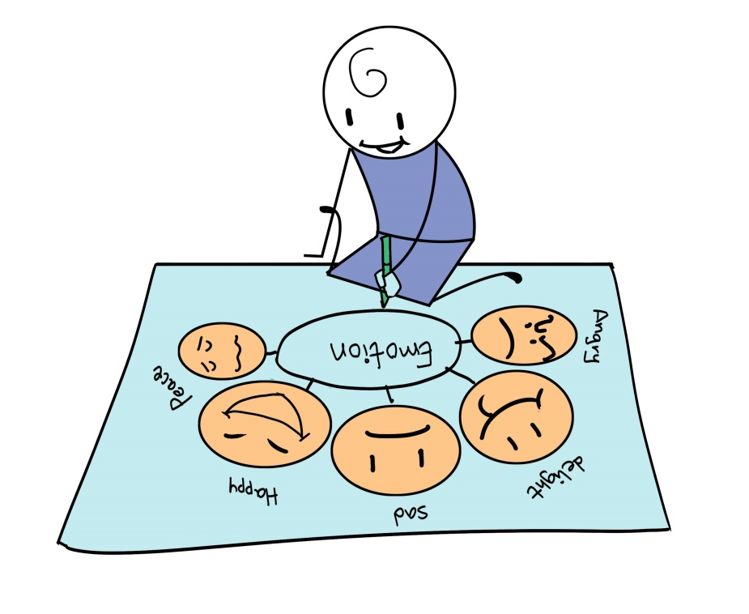

LET’S TALK!
- How can your reactions affect other people?
- How do your reactions affect you?
- What are some positive ways to deal with difficult emotions?

Variations
None specified

MY FRIENDS AND COMMUNITY

Friendship

Friendship

Aim
Discuss qualities of healthy relationships
Age | 6 and older
Time | 70 min
Materials
Colour pens/pencils, a large piece of paper, 4 pieces of paper (per child)
Instructions
- Draw a big circle on a big piece of paper.
- Draw a good friend in the middle.
- Call out the ways you can think of to be a good friend.
- Write/draw answers around the circle.
- Draw 4 pictures about “what I would like other children to do if…”:
  - I was sick
  - I was not at school, or had to leave school
  - I was being bullied
  - A member of my family was sick

LET’S TALK!

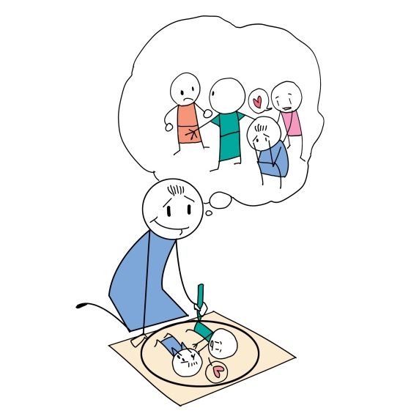
- Would it be easy to do these things for others? Why? Why not?
- Explain that being kind makes people feel good. We should always treat other people how we would like to be treated.

Variations
None specified

Taxi Game

Aim
Learn to trust
Age | All ages
Time | 20 min
Materials
None
Instructions
- Get into pairs. One person is a driver and the other is a taxi.
- The taxi closes their eyes. The driver moves them around carefully.
- Don’t talk!
- Switch roles.

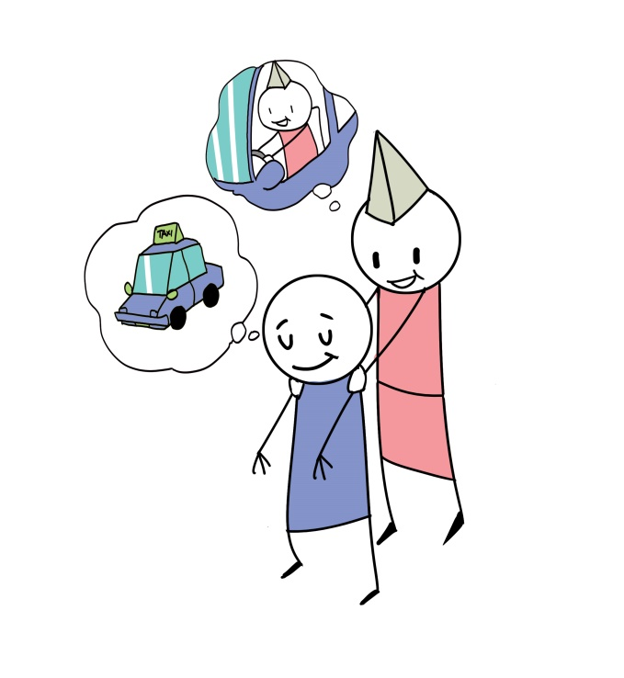

LET’S TALK!
- How do you know when you can trust someone? And when you can’t?
- How can you show others you are trustworthy?
- How did it feel to trust someone else?
- How was it to have someone else trust you?
- Why is trust important?
- What can create trust? What can break it?

Variations
Write a short story or create a short play about building or breaking trust.

I can Listen to Others

Aim
Active Listening
Age | 6 and older
Time | 20 min
Materials
None
Instructions
Activity 1: Practicing listening
- Play music or sing a song. Move around.
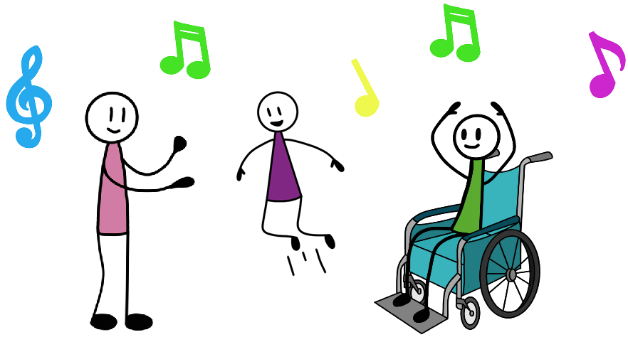
- When the music stops, grab a partner.
- Tell each other something that interests you. Listen without interrupting.
- Repeat back what your partner told you.
- Play again.

LET’S TALK!
- Did you enjoy talking or listening?
- Was it difficult to listen? If yes, why?
- How do you know someone is listening?
- Are you a good listener? Why/why not?
- Why is it important to be a good listener?

Variations
You can do this sitting down.
Say your partner’s name, instead of touching them.

My Garden of Support

Aim
Identifying people to turn to for support.
Age | 6 and older
Time | 70 min
Materials
Colour pens/pencils, paper
Instructions
- Draw a garden with a tree.
- Think of a person/people close to you, who you trust, love or look up to.
- Draw them in the garden

LET’S TALK!
- Why is it important to think about who matters in our lives?
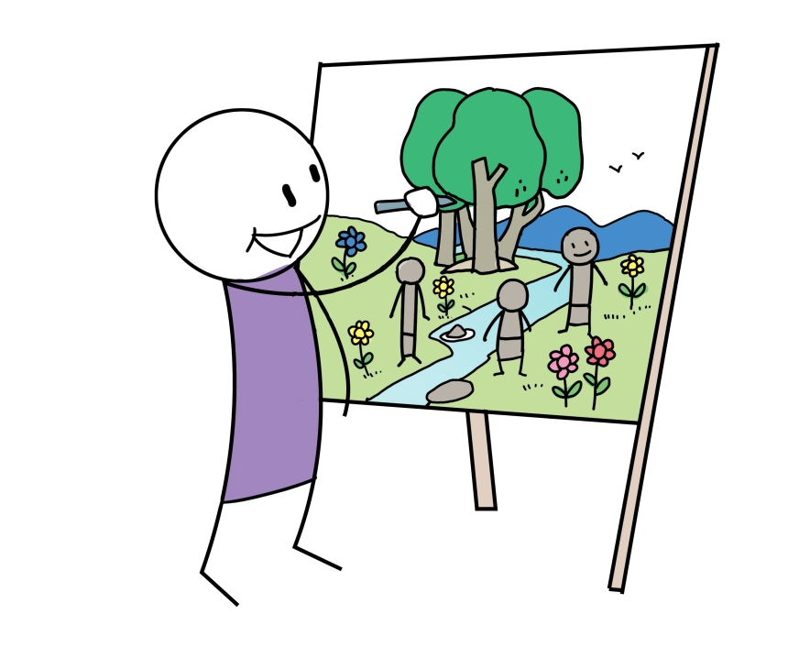
- What nice things you can do with these people?
- Who would you go to if you needed help?

Variations
- Use other positive places. Examples: a walk in a forest, mountains, a river or the sea, at home;
- Draw a hand, with each finger representing a person to go to for support.

Supporting Each Other

Lean on Me

Aim
Explore what friendship and trust means.
Age | All ages
Time | 20 min
Materials
None
Instructions
- Face each other, holding hands at shoulder height.
- Lean forwards onto the other and support each other.

LET’S TALK!
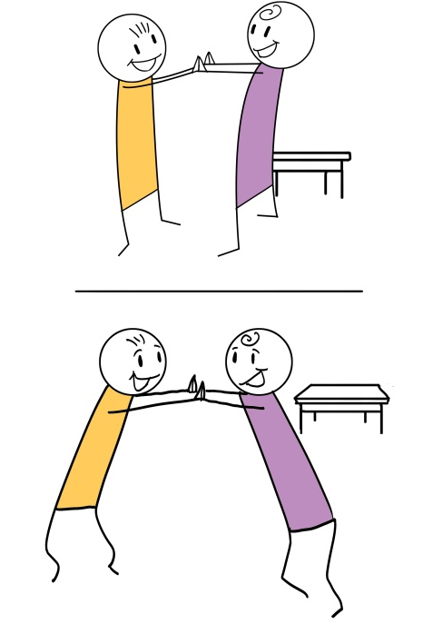
- How did you feel leaning on your partner?
- Did you trust each other?
- Why is it important to trust each other?
- What makes a good friend?
- Why do we have friends?
- What makes a friend “trustworthy”?

Variations
Close your eyes and rely more on touch and pressure. Vary the questions depending on age.
If physical contact is not appropriate, draw a picture of the qualities of a good friend. Then discuss.

Story Telling

Aim
Sharing positive memories and having positive thoughts
Age | 6 and older
Time | 40 min
Materials
None
Instructions
- Think about a positive event in your past. Examples: first day at school, your friends, something positive or funny.
- Think about the beginning, the characters, the main event, the feelings, the ending.
- Draw the story or write something about it

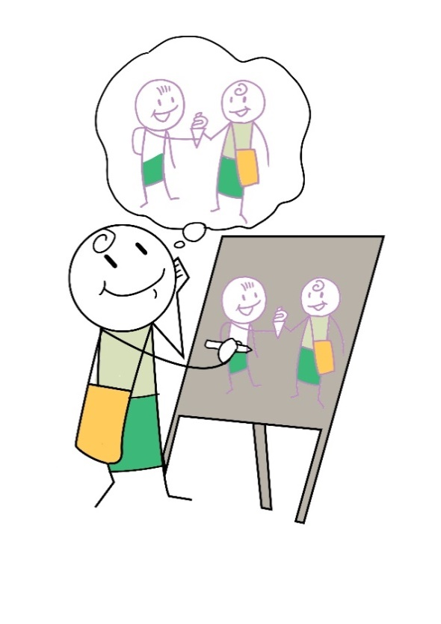
LET’S TALK!
- What was positive about your story? How does that make you feel?
- Is there anything you can learn from your story?

Variations
- Invent a story based on your dreams.
- Each choose a word. If your word is said when someone is telling a story, get up and walk around, then sit back down.
- Tell a joint story. Each person adds one sentence.

Sharing Positive Feedback

Aim
Encouraging positive feelings and identifying ways to support each other
Age | 6 and older
Time | 30 min
Materials
None
Instructions
- Say something positive about what someone else did during the day/week. Examples:
- “I liked the way you……”
- “Thanks for….”
- “I really appreciated that/when you…”
- “I learned… from you”
- “You did really well to…”
- “Thanks for supporting me to…”
- “I am proud of you when…”

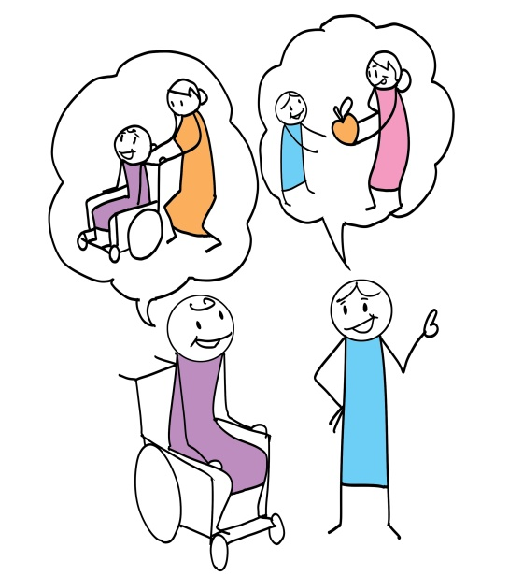
- Invent a positive story to tell according to the positive sentences.

LET’S TALK!
- What do others do to make you happy?
- How can others can be more supportive?
- What do you do to support others?
- How can you be more supportive and helpful?

Variations
Think of things you like about yourself or someone else. Examples: physical attributes, personal qualities, skills

Who is Your Hero?

Aim
Being hopeful
Age | 4 and older
Time | 30 min
Materials
Paper and pencils
Instructions
- Choose your favourite job or a person in your community who you think is a hero.
- Others try to guess it. Draw, act or give verbal clues

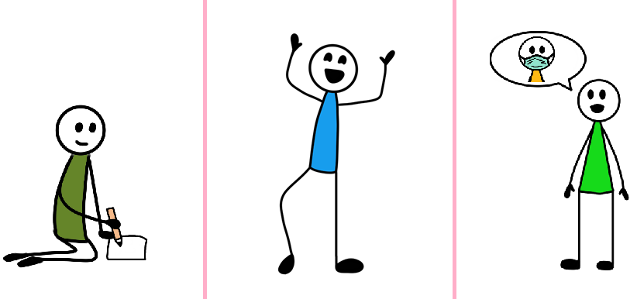
- Take turns

LET’S TALK!
- Who are the heroes in our community? Why? Think of girls, women, boys and men and how heroes can be different or have different roles.
- How does your hero help you feel hope?

Variations
None specified

I can Respect and Value People Who Are Different

Aim
Respect for differences
Age | 6 and older
Time | 30 min
Materials
Nothing
Instructions
- Each person chooses 1 role. Examples: Won’t talk, Won’t walk, Won’t see

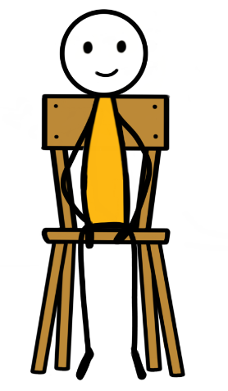  Won’t walk |   Won’t talk | 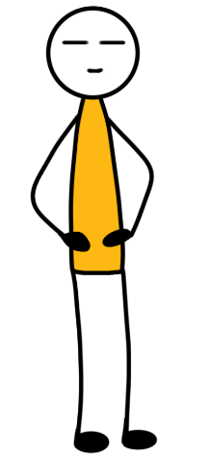  Won’t see

- Choose a letter of the alphabet
- Together, and in your roles, find as many things as you can that start with that letter.

LET’S TALK!
- Why is it good to play with girls and boys who have different ideas?
- Why is it important to treat people with respect?
- What can you learn from people who are different to you (can you give some examples)?

Variations
None specified

I can Respect and Value People who have a Disability

Aim
Respect for differences
Age | 4 and older
Time | 30 min
Materials
A ball (or anything that can be safely used as a ball)
Instructions
- Make a circle (or between 2 people). Pass the ball.
- Make a new rule. Example: if you are wearing blue you can only use one hand/foot.
- Play again. Change the colour. Example: if you are wearing red, you can only use one hand/foot.

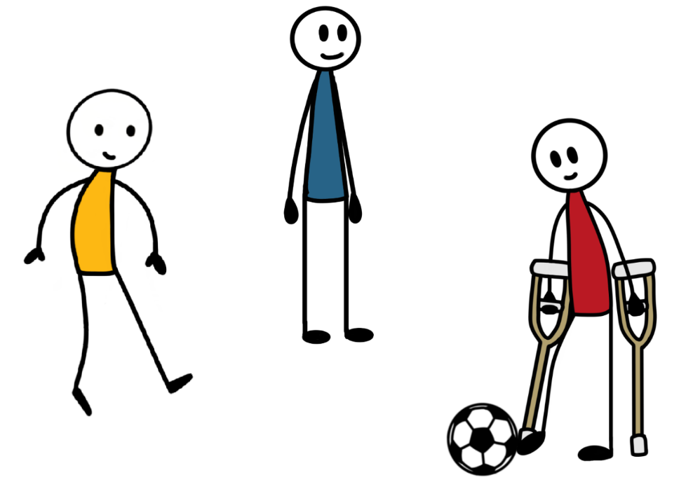

- Remind children that anyone around the world can get sick or have a disability. We should always be kind to others, and we should always be kind when we talk about others.

LET’S TALK!
- How did it feel to follow a different rule to everyone else?
- Why should we be kind to people who have a disability or are sick?

Variations
You can do this sitting down.

I can Understand How Others Think or Feel

Aim
Understanding others and being kind
Age | All ages
Time | 30 min
Materials
Something safe to put on your head (examples: sock, notebook, leaf)
Instructions
- Put the sock on your head and dance!
- Freeze if the sock falls
- Keep dancing if someone puts the sock back on your head.

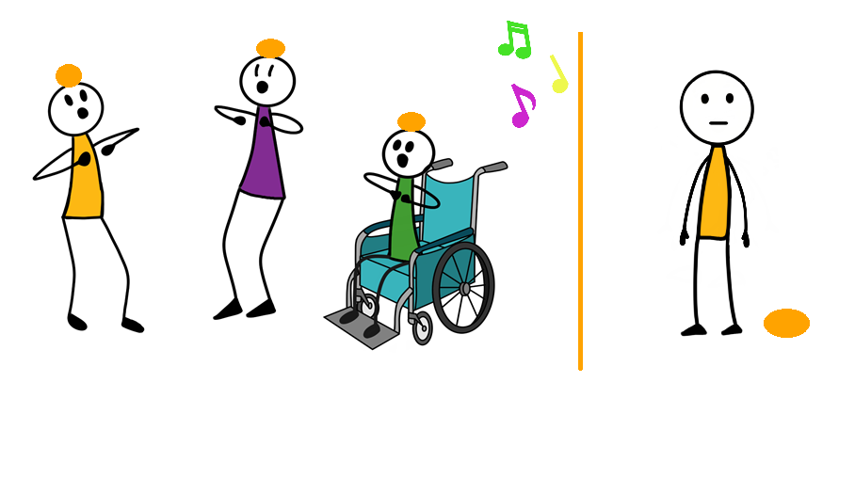

- Explain to children that people who are sick may feel sad, worried or scared. We should always think about how they are feeling, and be kind.

LET’S TALK!
- Why did you decide to help?
- How did you feel when someone helped you?
- Explain that kind words and acts make people feel good. Imagine something soft, like a blanket – that is what kind words feel like. Imagine something rough, like sand or a tree – that is what unkind words feel like. Each share examples of kind and unkind words you have heard. Were they soft or rough?

Variations
You can also do this sitting down.

We can Take Care of Our Home Together

Aim
Taking responsibility
Age | 6 and older
Time | 30 min
Materials
A ball (or anything that can be used as a ball)
Instructions
- Pass the ball around the circle as you sing a song.


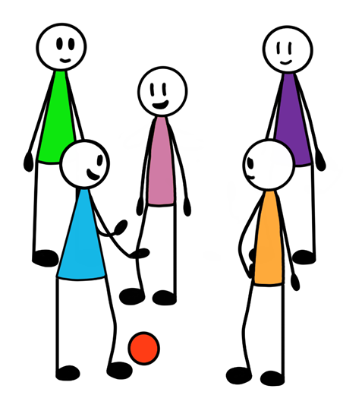
- When the song stops, the person with the ball goes in the middle.
- They will act out a job they do at home. The others will try to guess it.
- Play again
- Explain that it is important to share housework. Everyone (girls, boys, men and women) needs to help so that everyone can stay healthy and have time to play and learn.

LET’S TALK!
- What jobs need to be done at home?
- Why are they important?
- How can each person in the family help with these jobs?

Variations
You can do this sitting down.

We can Continue Our Daily Activities

Aim
Keeping a routine
Age | 6 and older
Time | 30 min
Materials
None
Instructions
- The leader says a day of the week
- Reach HIGH if they say Monday, Tuesday, Wednesday, Thursday or Saturday
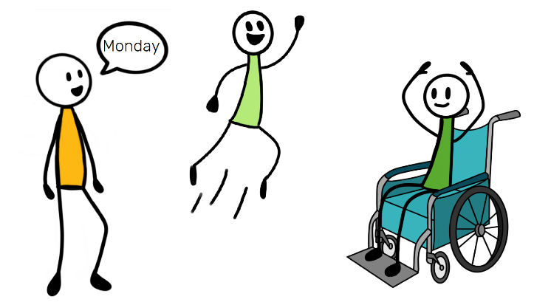
- FREEZE if they say Friday or Sunday
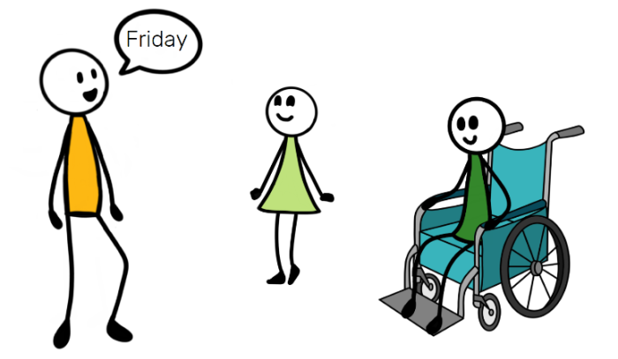
- If you do the wrong action, say one thing you always do on that day
- Remind children that even though they are at home more now, they can still do some of their regular activities. Doing regular activities helps you feel better. Structure helps people feel safe and know what to expect every day, even when the world is unpredictable.

LET’S TALK!
- What do you do every day at the same time?
- How do you want your day or week to look?
- Why is it important to keep a routine? Explain that having a routine provides a sense of normalcy and security, so that people know what to expect from the day.
Variations
You can do this sitting down.

We can Help One Another Make Healthy Choices

Aim
Helping each other
Age | 6 and older
Time | 30 min
Materials
None
Instructions
- The leader tells a story: Mary likes to climb trees and eat fruit. Once her dad came home with a basket of fruit. He asked Mary not to eat it. It was for his guests. Mary was so hungry and there were lots of fruits.
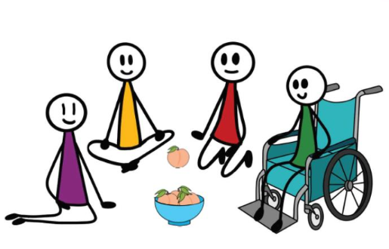
- Talk: What are Mary’s choices? What will happen if she makes each choice?
- Together make the best choice. Tell each other why you think it’s the best choice.

LET’S TALK!
- Did you ever need to choose between two choices? What did you choose? How did it impact others?

Variations
None specified

Our Colorful Faces

Aim
Working cooperatively
Age | 6 and older
Time | 40 min
Materials
Colour pens/pencils or paint, a piece of paper.
Instructions
- Draw your friend’s face.
- Decorate it with symbols and colours that represent them. Examples: culture, religion, personality, likes/dislikes, what you like about the person.
- If possible, give the picture (or a photo of it) to your friend.

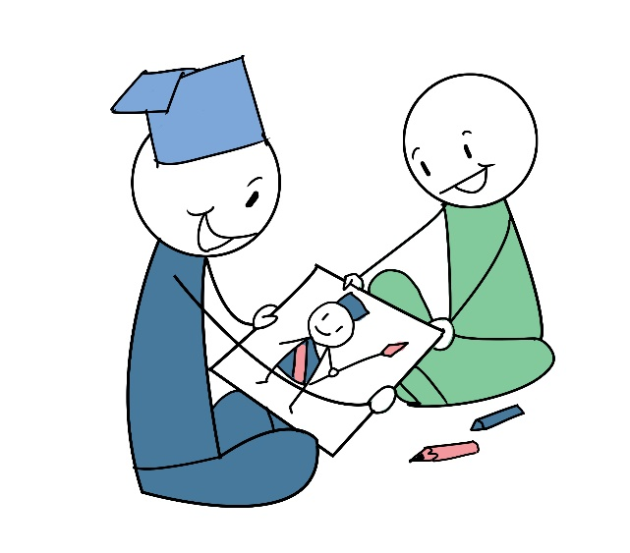

LET’S TALK!
- How did you decide what images to use?
- Did this make you think more about your friend’s character or background? What did you notice?
- Do you think you accurately portrayed them? Can you describe them?

Variations
None specified

Our Strengths

Aim
Identify personal strengths and explore ways to help the community.
Age | 6 and older
Time | 60 min
Materials
Color pens/pencils, paper
Instructions
Pair Interviews
- Think of some questions to ask you (or a sibling). Examples: school, jobs, family, what makes you happy, hobbies or what they do for fun, strengths or skills.
- Take it in turns to interview each other.
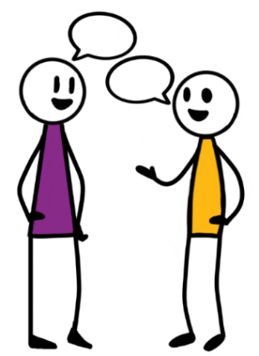
- Draw your strengths and how you will use these to help others.
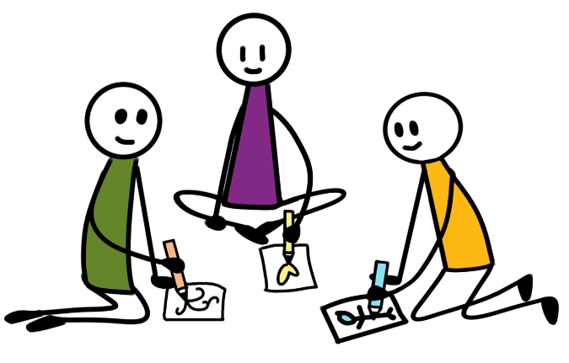
- Put your picture on the wall!

LET’S TALK!
Agree that only respectful and positive comments can be raised.
- What are your strengths/skills? And your partners?
- How can your strengths/skills be used to help others?
- How can your strengths/sills be useful in the future?
- Have you ever helped anyone?
Variations
None specified

Working Together

Aim
Positive communication and collaboration.
Age | All ages
Time | 20 min
Materials
A pencil (or a pen with a lid on it)
Instructions
- Face each other.
- Hold a pencil between your finger and your partner’s finger. Do this with 2 pencils, 1 on each hand.
- Step left, then right. Don’t drop the pencil!
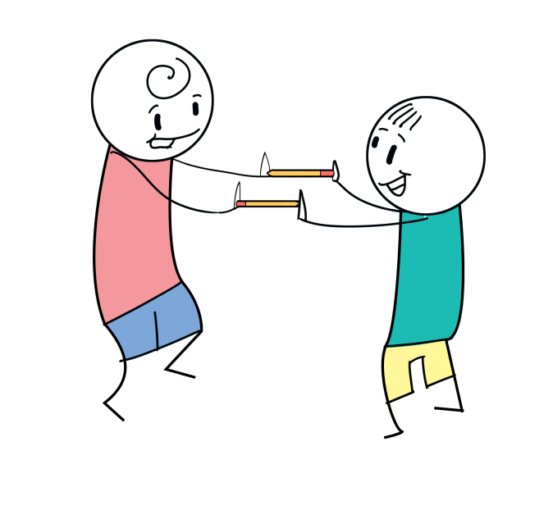

LET’S TALK!
• Was it difficult to keep the pencils balanced?
• How did you make it work?
• What did you learn about communication and patience?

Variations
If physical contact of proximity is not appropriate, do another collaborative activity, such as drawing a joint picture or writing a joint story. Then discuss.

MY HEALTH AND SAFETY

My Health

Clean Hands Detective

Aim
Practicing good handwashing
Age | All ages
Time | 20 min
Materials
Any small object.
Instructions
- Make a circle. The leader goes in the middle and closes their eyes.
- Pretend the object is soap. Pass it behind your backs as you sing a song.
- When the song stops, the leader tried to guess who has the ‘soap’
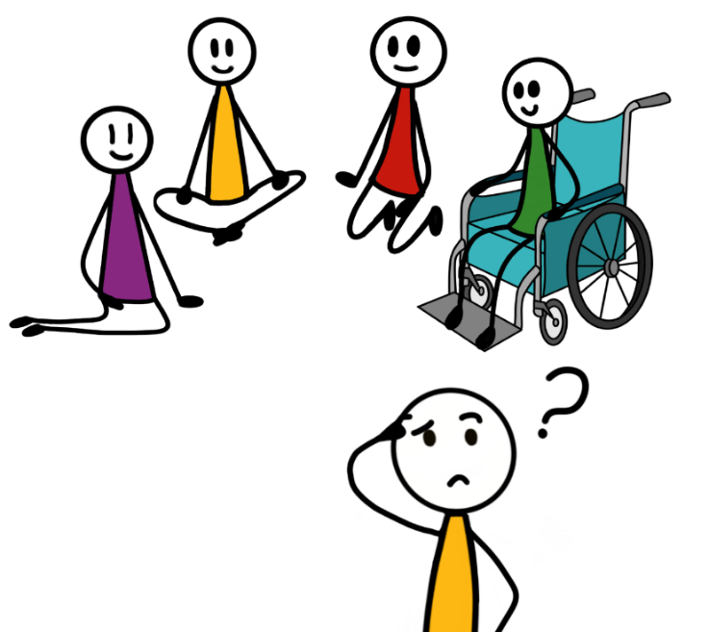
- Play again with a new leader.
- Remind them that washing our hands with soap and water for 20 seconds is a great way to protect ourselves from illnesses (including Covid-19).

LET’S TALK!
- Why is it important to wash your hands often?
- How long should you wash your hands for?

Variations
If physical proximity or touching a shared object is not appropriate, use a ‘fist’ behind your back to represent the soap. The leader has to guess which people have both hands in a fist, one hand in a fist, or both hands open.

I can Sleep Regularly

Aim
Talking about sleep
Age | All ages
Time | 20 min
Materials
None
Instructions
- Choose your favourite animal
- When the leader says ‘good morning’, act like that animal
- When the leader sys ‘good night’, pretend to sleep
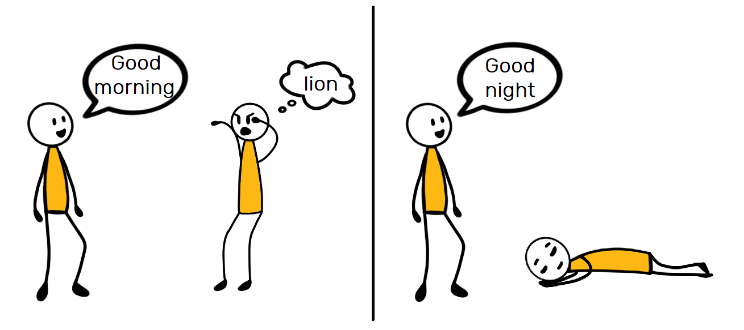
- The leader will say it faster and faster

LET’S TALK!
- How do you feel when you don’t sleep enough?
- Why is it important to sleep regularly and get enough sleep?

Variations
Use the words ‘sun’ and ‘moon’ to signify day and night. Think of actions the animal might do in the day or night.

I can Eat Healthily

Aim
Talking about nutrition
Age | 10 and older
Time | 20 min
Materials
4 pieces of paper
Instructions
- Ask your child/children to draw a picture for each food group:
  - Fruit and vegetables
  - Grains
  - Protein
  - Dairy
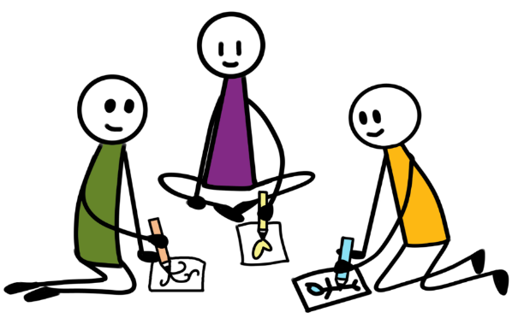
- Choose 4 places in the room and put a picture in each place
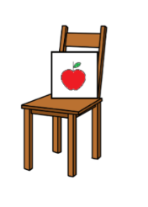
- When a leader says a food, go to the picture of the food group it belongs in.
- Whoever goes to the wrong place, is the new leader.

LET’S TALK!
- What healthy food can you eat today? Which food group is it in?
- Why is it important to eat healthily?

Variations
For younger children, you can draw pictures for each food groups and do the rest of the activity as explained.

I can Stay Active

Aim
Realising the importance of staying active
Age | All ages
Time | 20 min
Materials
None
Instructions
- Think of an action or movement. Show each other your actions.
- The first person does their action, then the action of another person, to pass the ‘go’ to them
- The next person does their action, then the action of another person and so on.

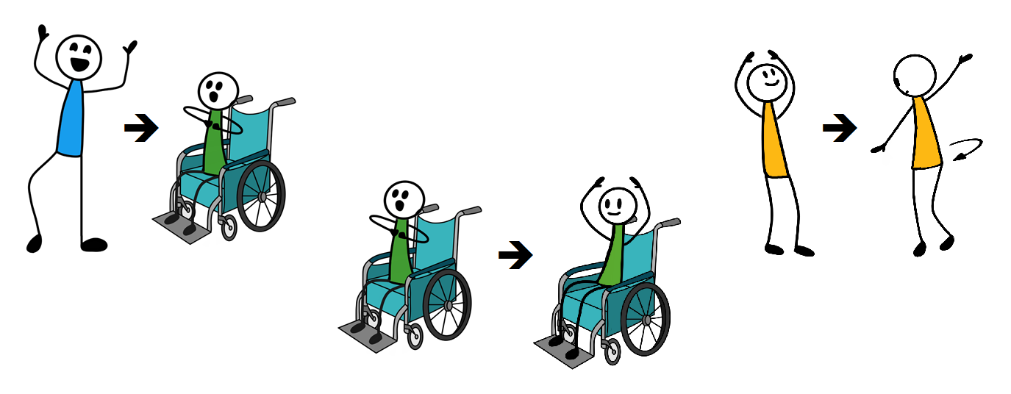

Remind children that it is important to move your body every day. Some ways to stay active are: dancing, playing games, walking, gardening or helping around the house.

LET’S TALK!
- Which action did you like most? Why?
- How will you be active tomorrow?

Variations
You can also do this sitting down.

We Can Stay Active Inside

Aim
Practicing balance and following instructions
Age | All ages
Time | 20 min
Materials
None
Instructions
- The leader will say different body parts (examples: 2 hands & 1 foot / 1 hand & 1 foot / 1 elbow & 2 knees / 1 elbow & 1 knee / 2 heels /1 heel)
- Put the body parts on the floor and balance yourself for 3 seconds

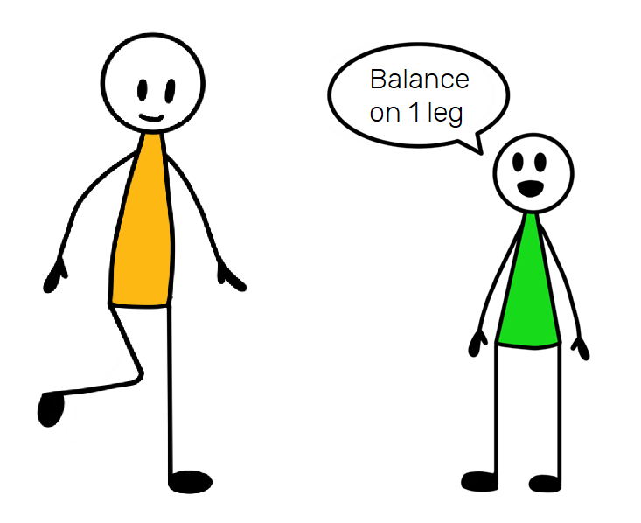
- If you can’t balance, do other fun actions, like making a dance!

LET’S TALK!
- Which task was hard? Why?
- Why should we all stay active while we are at home?
Variations
- Include instructions for the left and right sides of the body to practice telling the difference.

- If you have paper and different coloured pens/paint, draw coloured circles and place them on the floor to balance on (for example, put your left hand on red and your right foot on blue / put your left elbow on yellow and your left heel on green)

- The leader says an object. You have to touch it. Examples: something blue, your nose, a chair.

We Can Stay Active in Small Groups

Aim
Moving your body
Age | All ages
Time | 20 min
Materials
None
Instructions
- The leader will sing or play a song.
- Dance!
- When the music stops, FREEZE! The leader will try to make you laugh

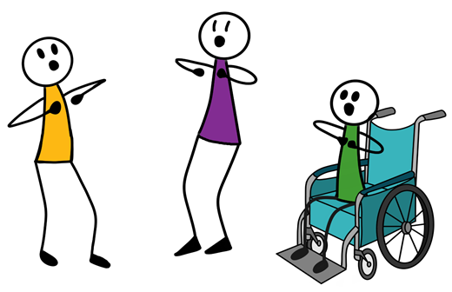

- If you laugh or move, help the leader make others laugh.
- Start the music again and dance again.

LET’S TALK!
- How do you feel when you are active?
- Can you think of other ways to stay active together at home?

Variations
None specified

I can Manage Stress

Aim
Being active together and reflecting on when to take a break
Age | All ages
Time | 30 min
Materials
A rope or scarf
Instructions
- Two people hold a rope or scarf between them
- Take turns trying to go under the rope
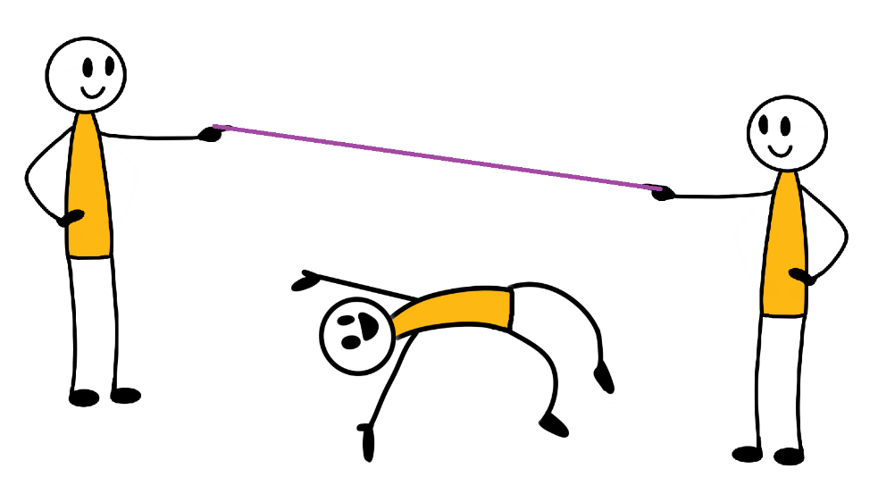

- Then hold the rope a bit lower. Try again!
- Stop when it is not comfortable to go under.

LET’S TALK!
- Why did you decide to stop?
- Why do you think it’s important to know when to stop? Explain that you should not do things that you are not comfortable with.
- Who can you talk to when you are uncomfortable or worried?

Too much news can make us scared, worried or stressed. Before this happens, we need to stop watching/listening and take a break. Knowing when to stop and take a break is really important, just like in the game.
Variations
None specified

Drawing Together

Aim
Express yourself collaboratively
Age | All ages
Time | 20 min
Materials
Colour pens/pencils, paper.
Instructions
- Choose a colour.
- Draw something just with this colour.
- After 2 minutes, pass the paper to the person on your left.
- Add to their drawing with YOUR colour.
- Pass the drawings every 2 minutes, until you have done a full circle. Look at your joint creations!

LET’S TALK!
- What did you like? What was difficult?
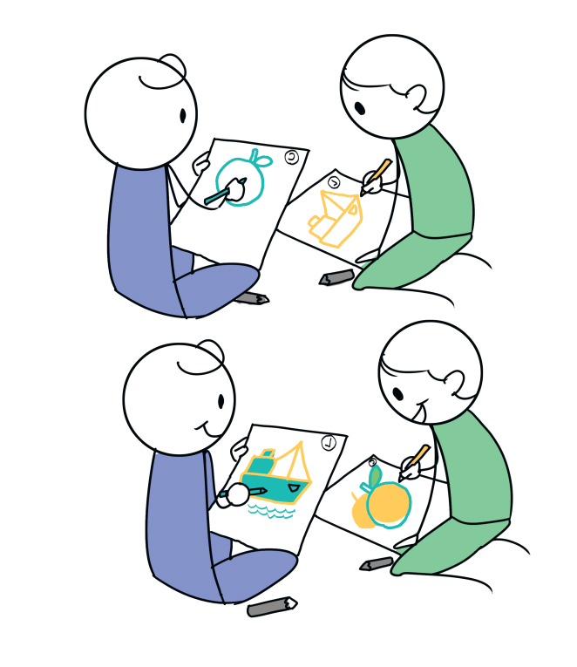
- Did what you draw change based on what others drew? Why or why not?
- How did you feel to be part of a larger work of art?
- In what other ways do you work with others?

Variations
- Give more time for younger children before passing to the next person.
- Draw the head of a person or animal. Fold the paper and pass it on. The next person draws the body. Then legs, then feet.

Paper Puppet Making

Aim
Identify issues, likes and dislikes.
Age | All ages
Time | 50 min
Materials
Any art material available (paper bags, buttons, string, cloth, scissors, tape, glue, socks etc)
Instructions
- Make a puppet. Decorate it. Give it hair, clothes, hands and feet, lips or eyes.
- Create a play or story about your puppet(s). Examples: a typical day, things you like/don’t like, something important in your life
- Do a show for your family or friends.
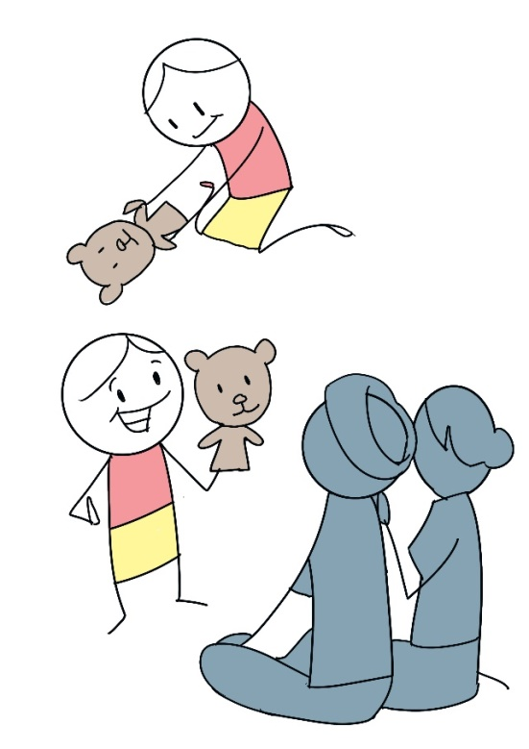

LET’S TALK!
- How does your puppet reflect its personality or feelings?
- What was the moral of your story/play?
Variations
- Write the play down as a script. Include multiple characters and involve the whole family.
- Instead of puppets, use a lamp and shadows of your hands or other objects to create characters.
- Give more time to younger children or create the puppets together.

My Safety

Tone and Body Language

Aim
Communicating using body language.
Age | 6 and older
Time | 20 min
Materials
None
Instructions
- Think of a statement. Examples: “I love to eat food”, “please give me the book”, “you are so kind”, “I believe in myself”.
- Choose an emotion. Examples: sad, happy, angry, tired, confused, afraid, embarrassed.
- Say and act your statement in that emotion.
- Try saying it using different emotions.

LET’S TALK!
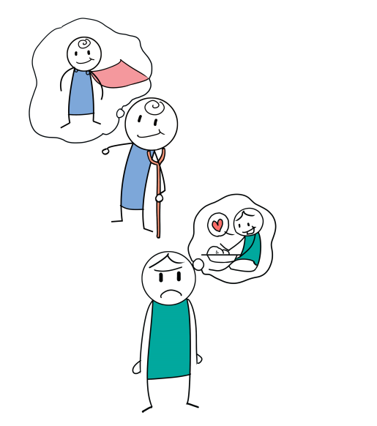
- Why is tone of voice and body language important?
- How can tone and body language help us to understand other people?
- Explain that body language and tone are strong expressions of feelings. They can make someone feel better or worse. Give an example: say “you are the best children ever!” using a happy voice, a tired voice, an angry voice. Ask “which one is the best tone to match the statement?”

Variations
Use the terms “non-verbal communication” and “verbal communication” when talking about body language and spoken language, respectively.

No- Go- Tell

Aim
Practice safety rules.
Age | 6 and older
Time | 70 min
Materials
None
Instructions
- Think about things you can do if someone is trying to hurt you or make you do something you don’t want to.
- Share your ideas.
- Practice these options:
- Say NO! with your hands out, palms away from you, and your face serious.
- GO. Run away (in a circle or on the spot)
- TELL someone you trust and ask them for help.

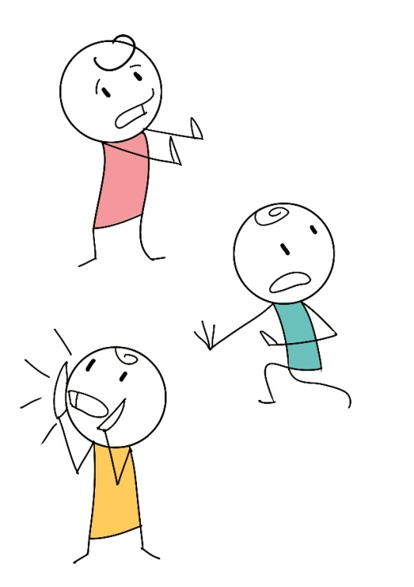
- It is a sign of strength to protect yourself. Never feel embarrassed or ashamed to tell someone.

LET’S TALK!
• Who is responsible for keeping you safe?
• Who can you ask for help?

Variations
Saying “NO!” or “STOP!” may not always work. Shouting “HELP!” or “FIRE!” may be more likely to get attention.
For older children, allow more dialogue about someone invading your personal space.

Community Mapping

Aim
Identify problems and sources of safety and support.
Age | 6 and older
Time | 70 min
Materials
Coloured pens/pencils, piece of paper.
Instructions
- Draw a picture of your community. Include people’s houses, schools, hospitals, roads, rivers, woods etc.
- Mark the places or people that are important to you.
- Mark the places that are safe for children (in green for ‘go’).
- Mark places where you do not feel safe (in red for ‘no go’). Examples: buildings, roads, places you may feel threatened.
- Draw or write ideas for what could be made better or safer.

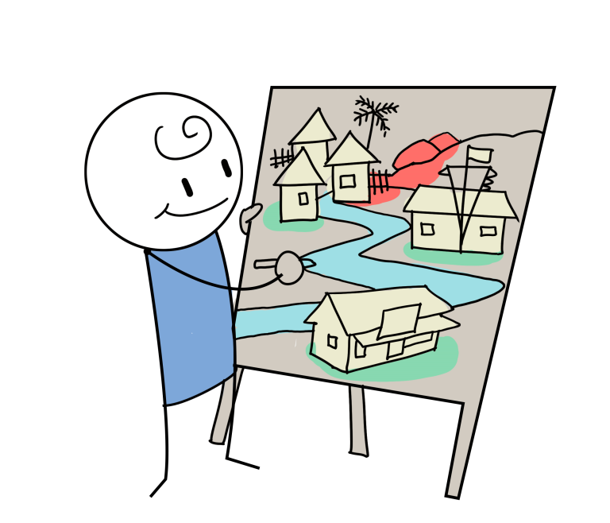

LET’S TALK!
- How do you know where is safe and dangerous?
- How can you avoid unsafe places?
- How can we make things better and safer? Whose help do we need to do this?

Follow up any good ideas with parents, teachers or community leaders.

Variations
Help young children with writing or drawing, if appropriate.

MY BRAIN

Focus and Plan

I can Remember

Aim
Memory
Age | 4 and older
Time | 20 min
Materials
Any household objects
Instructions
- Put 10 objects on the floor
- Close your eyes. The leader takes 1 object away.
- Open your eyes and try to guess what is missing.

LET’S TALK!
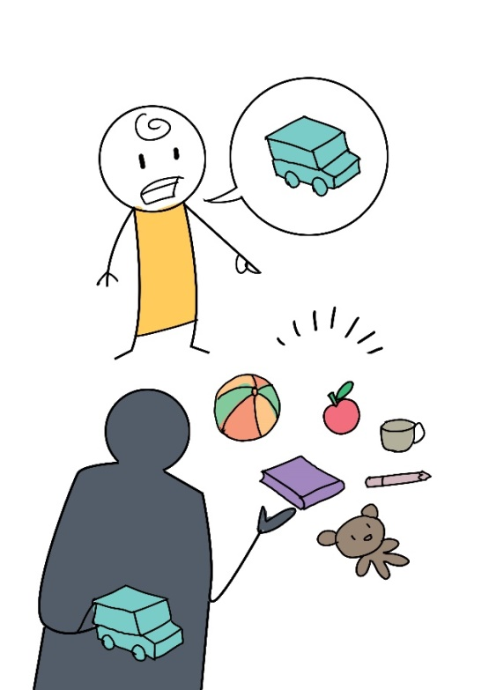
- Was it difficult to remember what was there?
- How did you try to remember the objects?

Variations
Use more or less objects depending on age group.

Younger children can participate by being the ones taking one object away. The others have to guess which one.

Memory Market

Aim
Memory
Age | 6 and older
Time | 20 min
Materials
None
Instructions
- Player 1 thinks of an object and says, ‘I went to the market and I bought________’. Example: an apple.
- Player 2 repeats what Player 1 says and adds their own object. Example: ‘I went to the market and I bought and apple and a bag of rice’.
- Keep going, adding to the list, until you get stuck.
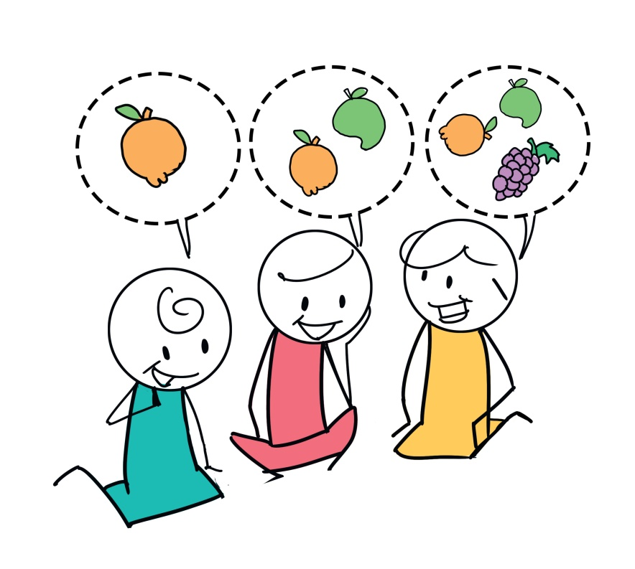

LET’S TALK!
- Was it difficult to remember the objects?
- How did you try to remember the objects?

Variations
Use more or less complicated objects depending on age group. Use unrealistic or imaginary objects, and introduce different adjectives to make it more difficult.

This Reminds Me

Aim
Linking words
Age | 6 and older
Time | 20 min
Materials
None
Instructions
- Say a word out loud. Example: apple
- The next person says a word that somehow links to your word. Example: tree, pie, orange

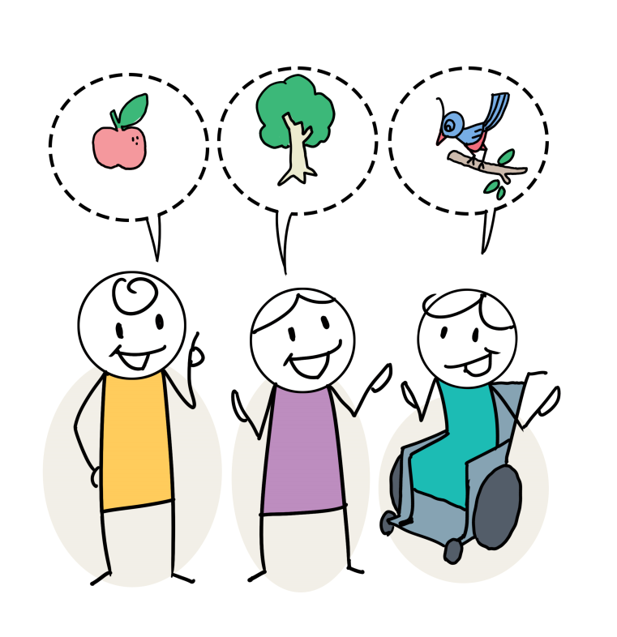

- Keep going. If the word doesn’t link to the previous word, you lose.

LET’S TALK!
- Was it difficult to think of words? What made it more or less difficult?

Variations
Try only allowing words that do NOT link in any way to the previous word.

I Can Focus on a Task and Ignore Distraction

Aim
Focusing
Age | 6 and older
Time | 30 min
Materials
None
Instructions
- Each person chooses a fruit. Think of an action for each fruit. For example: Apple = stand, banana = sleep, carrot = raise your hand
- The leader tells a story about fruit.
- When they say a fruit, do the action of that fruit.

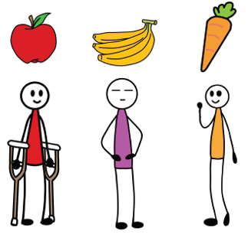
Sleep
Stand
Raise your hand

LET’S TALK!
- What helped you stay focused?
- Why is it important to stay focused?

Variations
You can also do this sitting down.

I Can Work with Others

Aim
Staying focused on a task
Age | 6 and older
Time | 30 min
Materials
Pencils or pens and paper
Instructions
- Put a piece of paper on the table.
- The leader will say what to draw. Examples: boat, house, lion
- The first person will go to the paper and draw for 10 seconds.
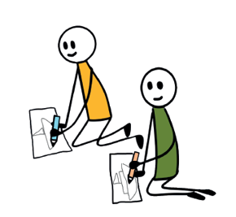
- After 10 seconds, they stop and the next person continues the picture
- Continue until the drawing is finished.

LET’S TALK!
- Which drawings were hard to do? Why?
- What was nice about working together to finish the drawing?
- What was challenging about working together to finish the drawing?
- What tasks at home are hard to do, but you don’t give up on?

Variations
None specified

We can Learn to Concentrate

Aim
Practicing concentration
Age | All ages
Time | 30 min
Materials
None
Instructions
- Listen carefully to the leader
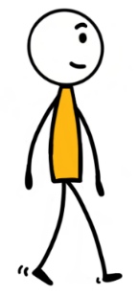
- Try to go faster
- If they say:
- “IN the water” go forwards one step

- “ON the water” stay still
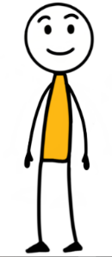

- “ON the sand”, go back one step
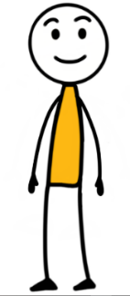
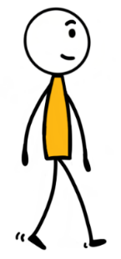
  - “IN the sand”, stay still

LET’S TALK!
- When is it hard to focus?
- How can you focus when it is hard?
Variations
None specified

We can Learn to Plan Our Day

Aim
Planning
Age | 6 and older
Time | 30 min
Materials
Pencils, paper and a ‘start line’
Instructions
- What is it important for you to do every day? Draw or write each one on a piece of paper. Examples: brush teeth, practice reading, eat lunch, sleep, play
- Fold the papers. Throw them in front of the ‘start line’
- Work together to get the papers. You can only touch the ground in front of the start line with your hands.
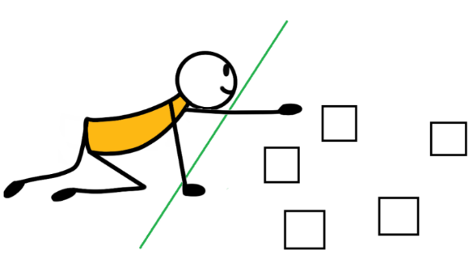

- Together, make a plan of different activities to do at the same time every day

LET’S TALK!
- What will you do at the same time every day?
- Why is it important to have a plan?

Variations
None specified

We can Learn to Ask for Help

Aim
Asking for help
Age | All ages
Time | 30 min
Materials
2 small objects, clock
Instructions
- Close your eyes. The leader will hide 2 objects.
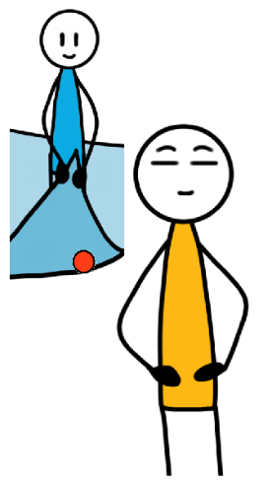
- Try to find them in 5 minutes
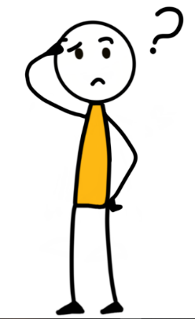

- If you need help, you can ask the leader 3 questions

LET’S TALK!
- When are the times we need to ask for help?
- Why is it important to ask for help?

Variations
Give hints. Hot = very close, Warm = quite close, cold = far.

Why? Because

Aim
Writing together
Age | 6 and older
Time | 30 min
Materials
Pencil and paper
Instructions
- Each write a question that starts with ‘why’. Example: Why do dogs bark?
- Fold the paper over so you can’t see the question and pass it on.
- Write a sentence that starts with ‘because’. Example: Because chocolate tastes good.
- Unfold the paper and see what it says!
- Think about the real answers to the questions

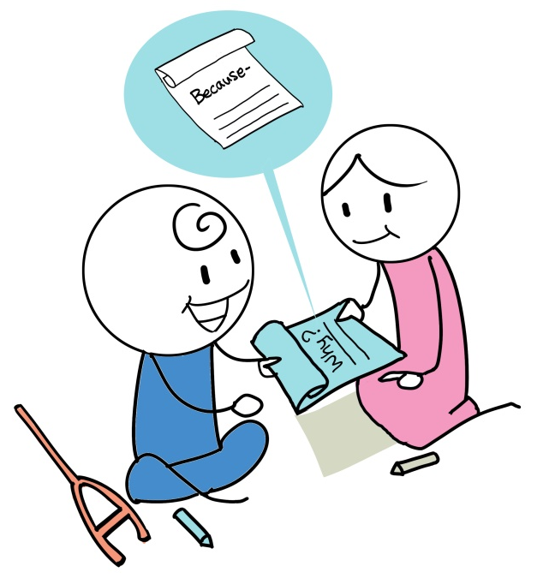

LET’S TALK!
- Do you know any of the answers to the questions?
- How can you find out the answers?

Variations
None specified

Stop

Aim
Practicing letters and words
Age | 10 and older
Time | 30 min
Materials
Pencil and paper
Instructions
- Each draw a table with 8 columns, as below:
- Chooses a letter. Put it in the ‘letter’ column.
- Write a word in each column that starts with the chosen letter and links to the column title.
- Whoever finishes first says ‘STOP’
- If you are the only person with that word, you get a point.
- Add up the total scores in the ‘total’ column. The most points wins!
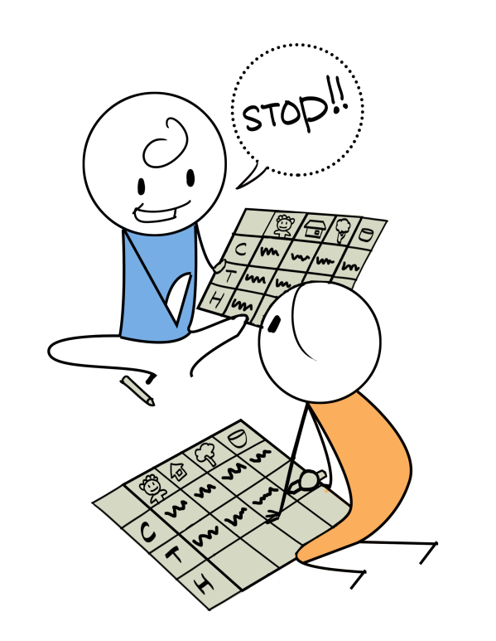

LET’S TALK!
- Which letters were most difficult? Why?

Variations
None specified

The Spelling Face

Aim
Spelling
Age | 6 and older
Time | 30 min
Materials
Pencil and paper
Instructions
- Choose a secret word and draw a line for each letter. Example: __ __ __ __ __ __
- Others guess letters that might be in your word
- If they are correct, write the letter where it belongs. __ E __ __ __ __
- If they are wrong, draw a part of a sad face. Example: face, eyes, nose, ears, hair, mouth
- If they guess the whole word, they WIN. When the face is completed, they LOSE.
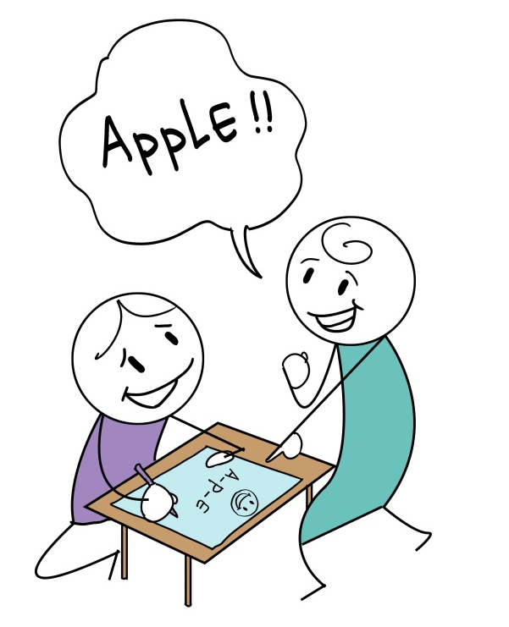

LET’S TALK!
- Which letters are the most common? And the least?

Variations
Use appropriate words for each age group.
Give the face more or less features to make the game easier/harder.

We can Love and Practice Reading

Aim
Reading together
Age | All ages
Time | 30 min
Materials
A story book
Instructions
- One person will read the story slowly
- Act out the story as you listen

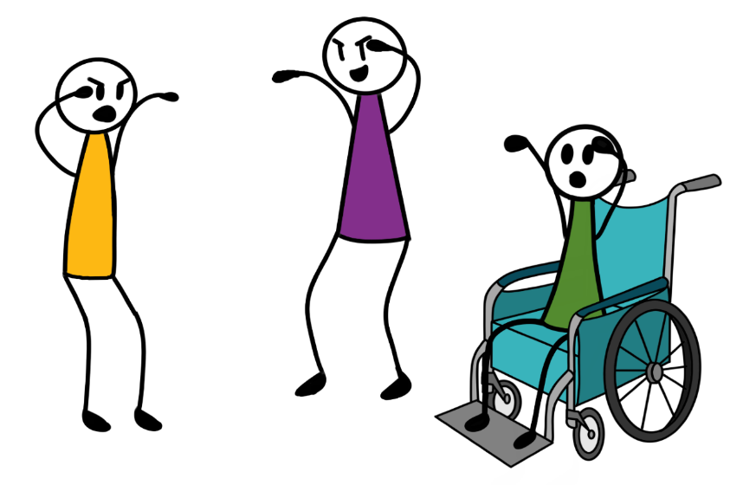
- Take turns reading different parts

LET’S TALK!
- Which part was the most fun to act out?
- When can we read more stories?
- What did you learn from the story?

Variations
None specified

Squares

Aim
Problem solving
Age | 6 and older
Time | 30 min
Materials
Pencil and paper
Instructions
- Draw dots in a grid.
- Take it in turns to draw a line between 2 dots. Diagonal lines are not allowed.
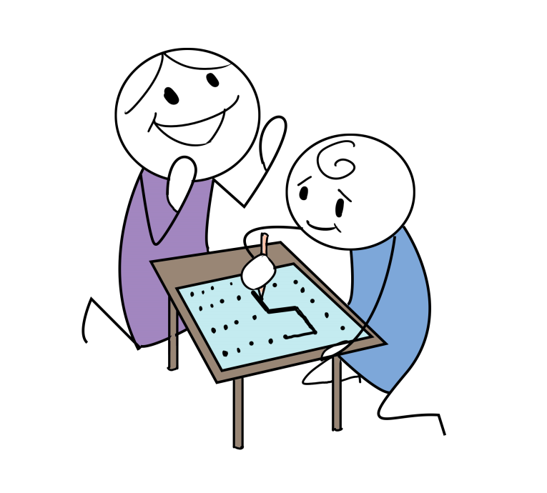
- If you add the last line to make a square, it is yours! Put your initial inside it and have another turn.
- The person with the most squares wins.

LET’S TALK!
- What is easy/difficult about this game?

Variations
- Use more/less dots to make the game easier/harder.

COVID-19

Activities for Covid-19

Virus Catch

Aim
Practicing social distancing
Age | 4 and older
Time | 20 mins
Materials
A ball or anything you can safely throw (stuffed toy, plastic bottle)
Instructions
- Pass the ball to your partner
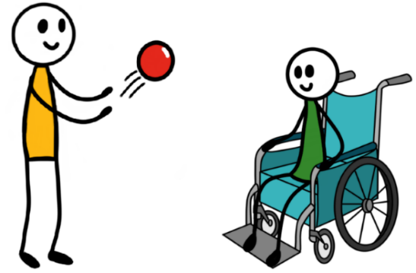
- After each pass, take one step back
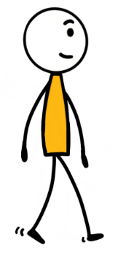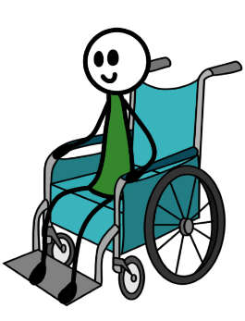

- If the ball drops, see how far you are from each other. Are you 2 metres (6 feet) apart?
- Keep playing

LET’S TALK!
- Why is it important to keep a distance from people at this time?
- Why is it important to keep other people healthy?
Variations
If physical proximity or touching a shared object is not appropriate, instead of using a ball, the leaders says ‘GO’. Count to yourself until they say ‘STOP’. Step back that many paces.

I can Share Information I Know is True

Aim
Sharing information and knowing what is true
Age | 6 and older
Time | 20
Materials
None
Instructions
- One side of the room is TRUE. The other side is FALSE.
- The leader will read the sentences below, one by one. Add more questions if you wish.

TRUE | FALSE
We should wash our hands with soap for 20 seconds | I don’t need to wash my hands more than once a day
You should cover your face with a tissue, face mask or handkerchief when you sneeze of cough | Sneezing and coughing do not spread the virus
You can help stay healthy with good sleep and nutrition | Eating fast food is good for your health

- If you think it is true, go to the TRUE side. If you think it is false, go to the FALSE side.
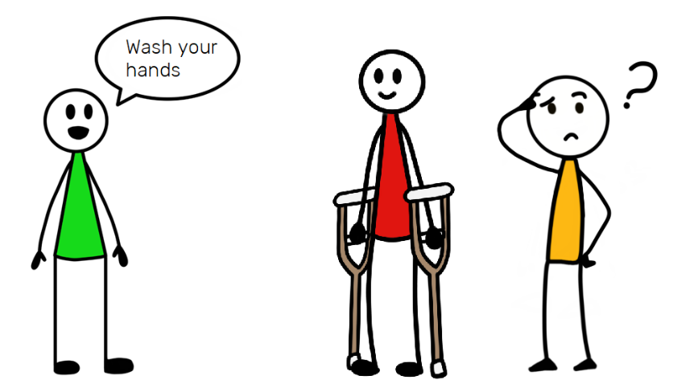

LET’S TALK!
- Which statements are true? Not true?
- Why is it important to only share information that is true?
- What will you do if you are not sure of the information you want to share?
Variations
Add more statements, based on WHO or national guidance.

I can Challenge Myths and Stereotypes

Aim
Challenging stereotypes
Age | 6 and older
Time | 20
Materials
None
Instructions
- Say the following statements one at a time and ask children to say which are FACT and which are FICTION

FACT | FICTION
Covid-19 passes easily from person to person | You cannot get Covid-19 from touching objects or furniture
Anyone around the world can get Covid-19 | Only children and old people can get Covid-19
Washing your hands properly helps protect you from Covid-19 | If you have some signs of the virus you shouldn’t go to the doctor unless it gets worse

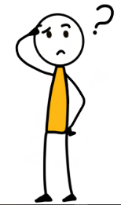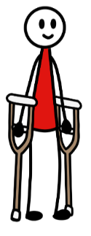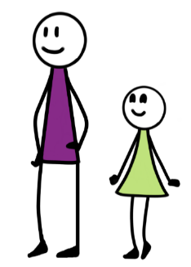LET’S TALK!
If you have signs of the virus, you shouldn’t go to the doctor
Washing
your hands helps protect you from COVID-19
You cannot get COVID-19 from objects
COVID-19 passes easily
Fact
Fiction
Only old people can get COVID-19
- What did you learn about Covid-19?
- What will you tell others about Covid-19? Why?
Variations
None specified

Coloring for wellbeing
Aim
Learn about Covid-19 prevention while having fun and developing creative skills
Age | 4 and older
Time | 30 min per message/picture
Materials
Coloring Book and coloring pencils
Instructions
1. Open your Coloring Book and choose a message
2. Read the message with the help of an adult if necessary
3. Do the coloring/drawing exercise

LET’S TALK!
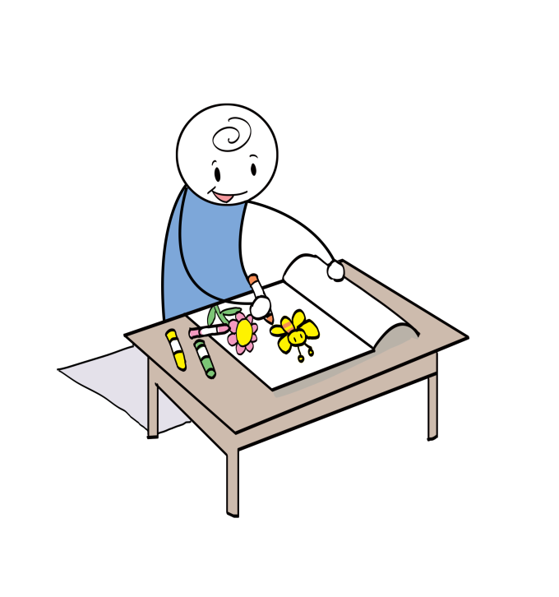
- Why is this message important?
- How could you apply the message in your daily life?
- How difficult it is to color?

Variations
- Do your own drawing for each message and share with your friends or put them up around the house or community

Write your name or draw a picture under each activity that you have finished!



Me and My Emotions | My Friends and Community | My Health and Safety | My Brain | Covid-19
Tree of Life | Friendship | Clean Hands Detective | I can Remember | Virus Catch
My Flag | Taxi Game | I can Sleep Regularly | Memory Market | I can Share Information I Know is True
Mirror in the Box | I can Listen to Others | I can Eat Healthily | This Reminds Me | I can Challenge Myths and Stereotypes
River of Life | My Garden of Support | I can Stay Active | I can Focus on a Task and Ignore Distraction | Coloring for Wellbeing
Balance Yourself | Lean on Me | We can Stay Active Inside | I can Work with Others
Muscle Relaxation | Story Telling | We can Stay Active in Small Groups | We can Learn to Concentrate
Things that Make me Happy | Sharing Positive Feedback | I can Manage Stress | We can Learn to Plan Our Day
I Can Calm Myself Down | Who is Your Hero? | Drawing Together | We can Learn to Ask for Help
Being Mindful | I can Respect and Value People who are Different | Paper Puppet Making | Why? Because
I am Aware of My Emotions | I can Respect and Value People who are Sick | Body Language | Stop
I Can Name and Describe My Emotions | I can Understand How Others Think or Feel | No-Go-Tell | The Spelling Face
I Can Share My Ideas and Feelings | We can Take Care of Our Home Together | Community Mapping | We can Love and Practice Reading
Expressing Feelings and Fears | We can Continue Our Daily Activities |  | Squares
Mirror Game | We can Help One Another Make Healthy Choices
I can Deal with Difficult Emotions | Our Colourful Faces
 | Our Strengths
 | Working Together

Stay Well. Stay Healthy. Stay Safe.

With Special Thanks to Right To Play for sharing their activity ideas and illustrations.

